NEW ZEALAND LANDSCAPES
A Photographic Collection

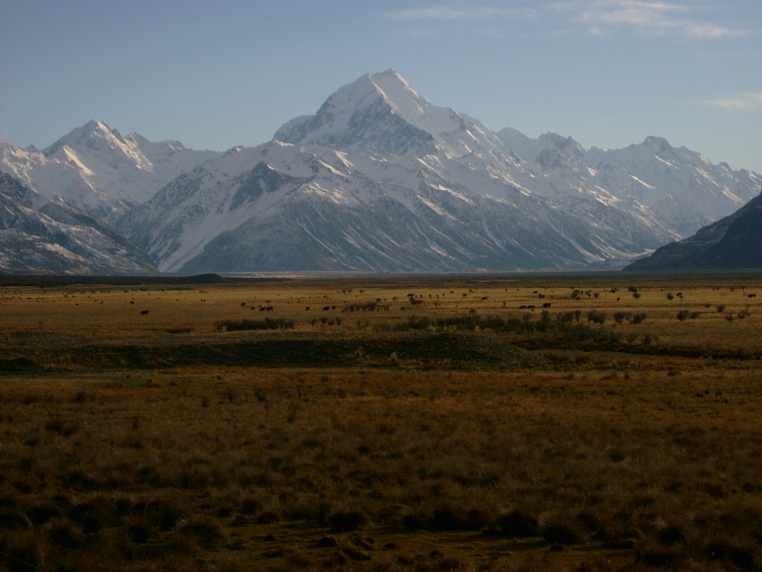

Published by A. Greenhead, New Zealand, 2023. Second Edition: October 2025.
Copyright © Alan Greenhead, 2023 All rights reserved.
www.planetbob.yolasite.com agreenhead2@gmail.com

Locations (in photo order):
1 Motuariki Island, Lake Tekapo
2 Mangawhai Heads
3 Hooker Valley, Mount Cook
4 Mount Cook
5 Lake Pukaki
6 Te Paki Dunes, Cape Reinga
7 Lake Tekapo
8 Manukau Heads, Auckland
9 Fox Glacier
10 Hooker Valley, Mount Cook
11 Lower Nihotupu Dam, Auckland
12 Tupare Gardens, New Plymouth
13 Near Eltham
14 Castlepoint
15 Whiritoa Beach, Coromandel Peninsula
16 Lake Mapourika
17, 18 Mount Taranaki
19 Whitecliffs Walkway, Taranaki
20 Back Beach, New Plymouth
21 Tongaporutu
22 Wai-iti Beach, Taranaki
23, 24 Lake Karapiro
25 Moturoa Island at sunset, New Plymouth

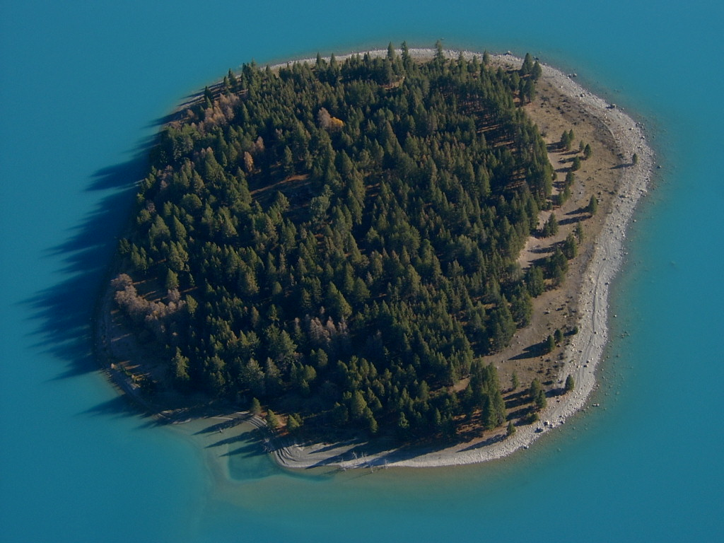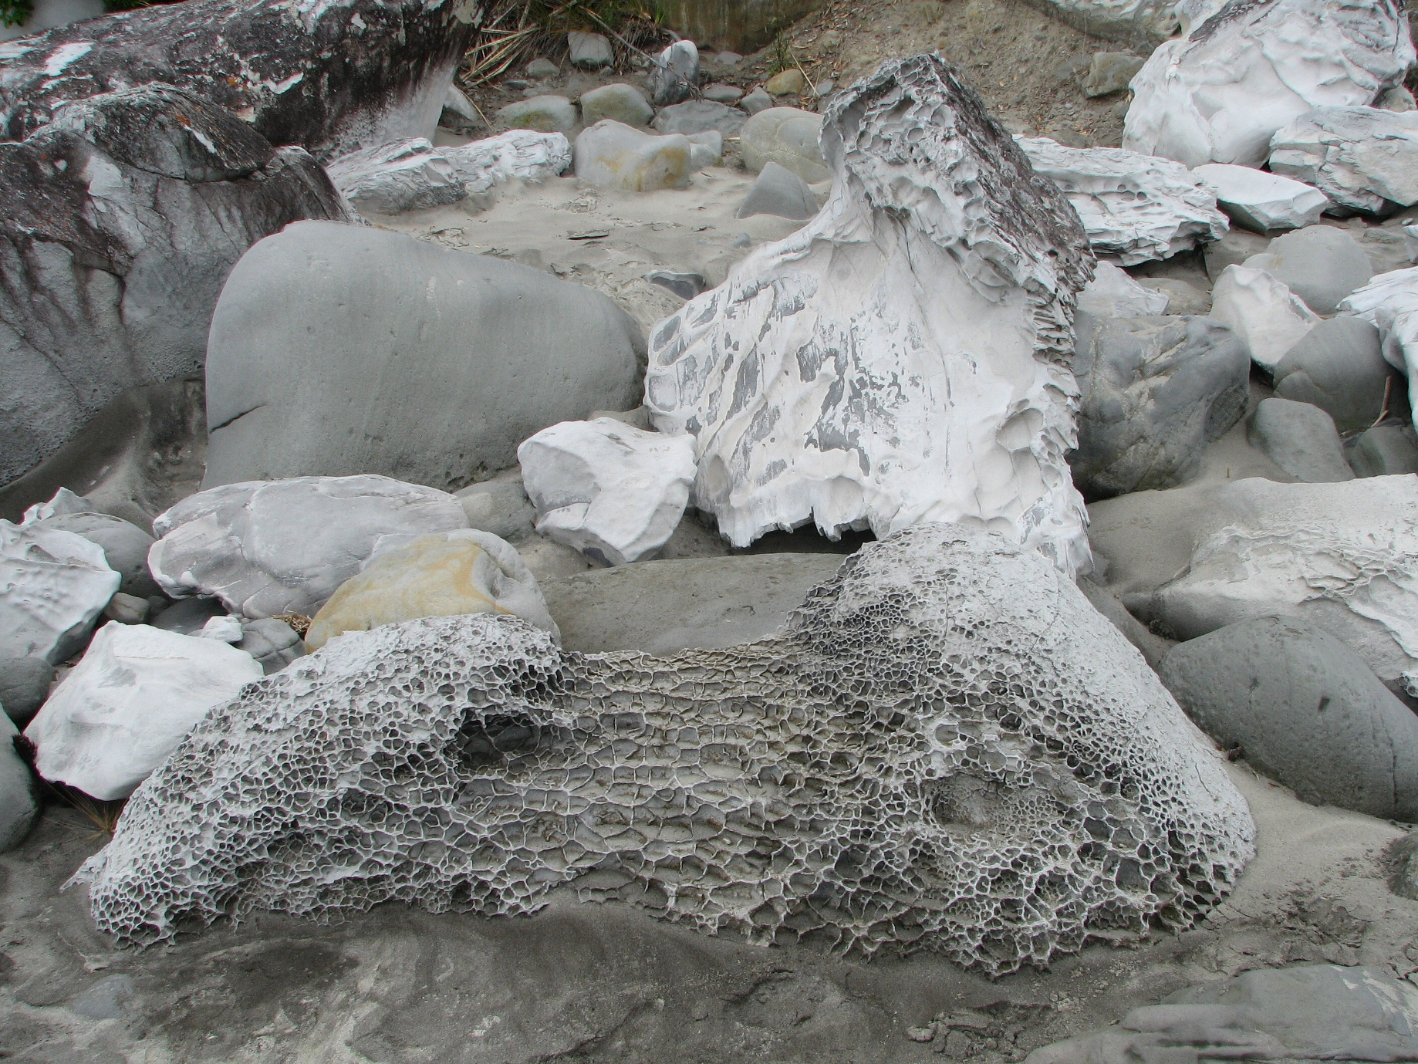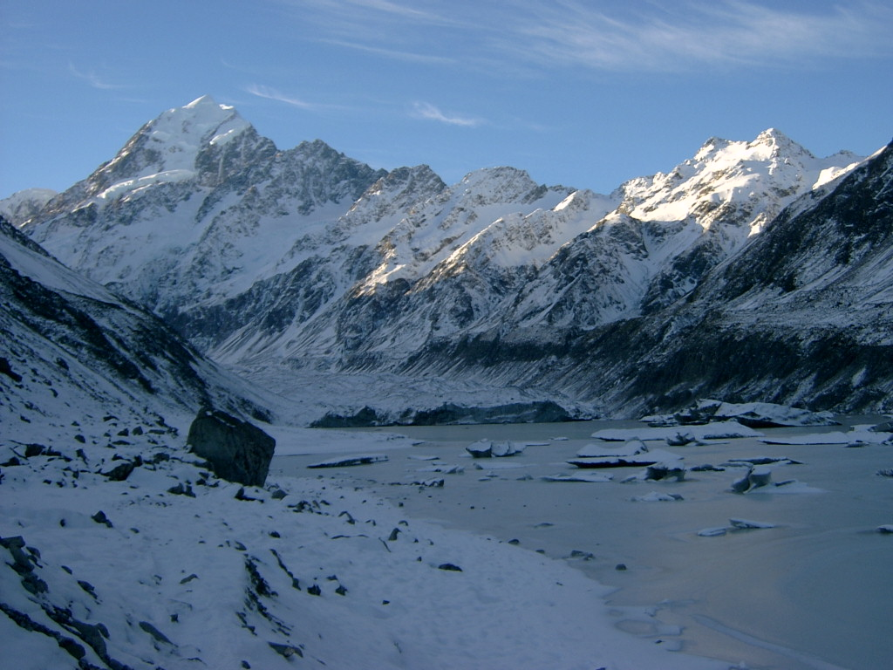
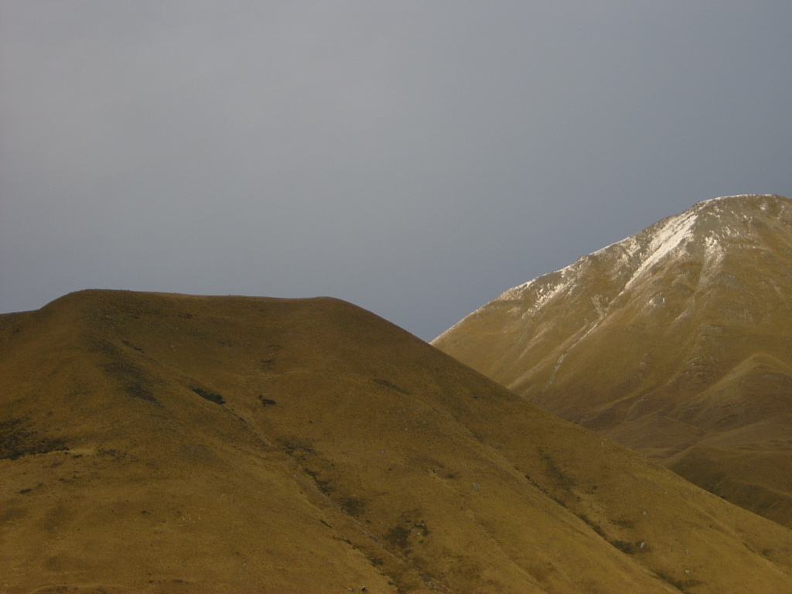
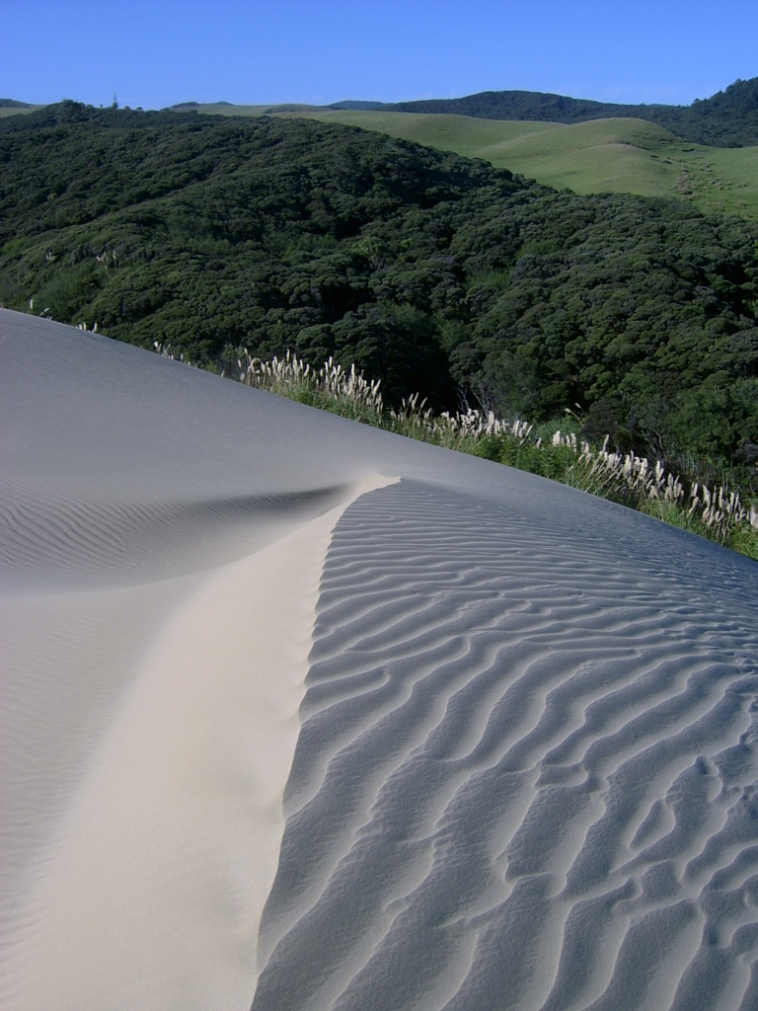
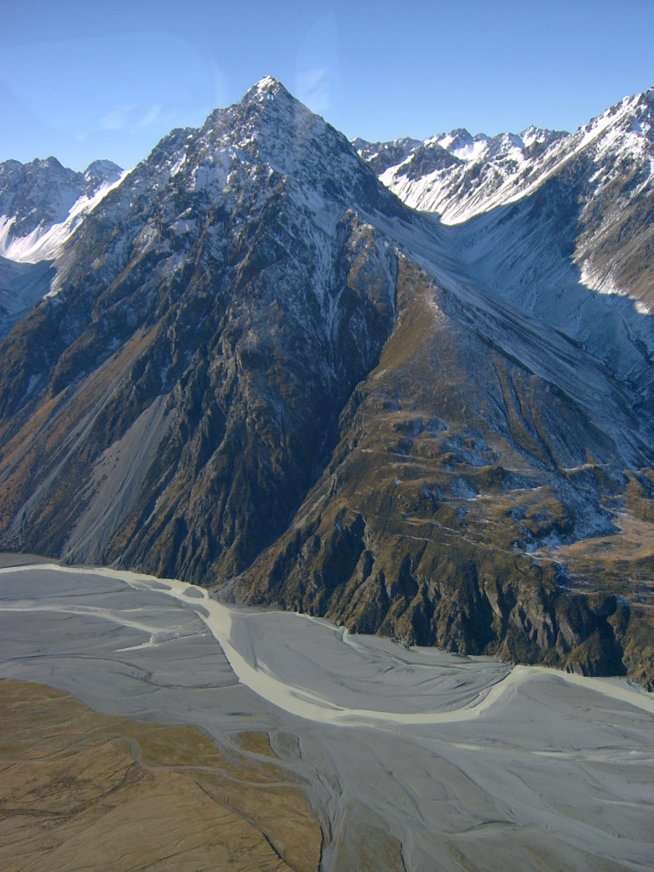
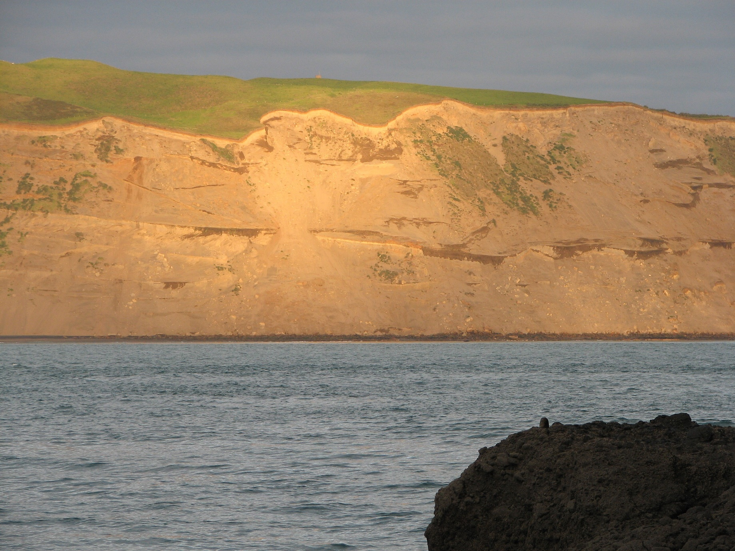
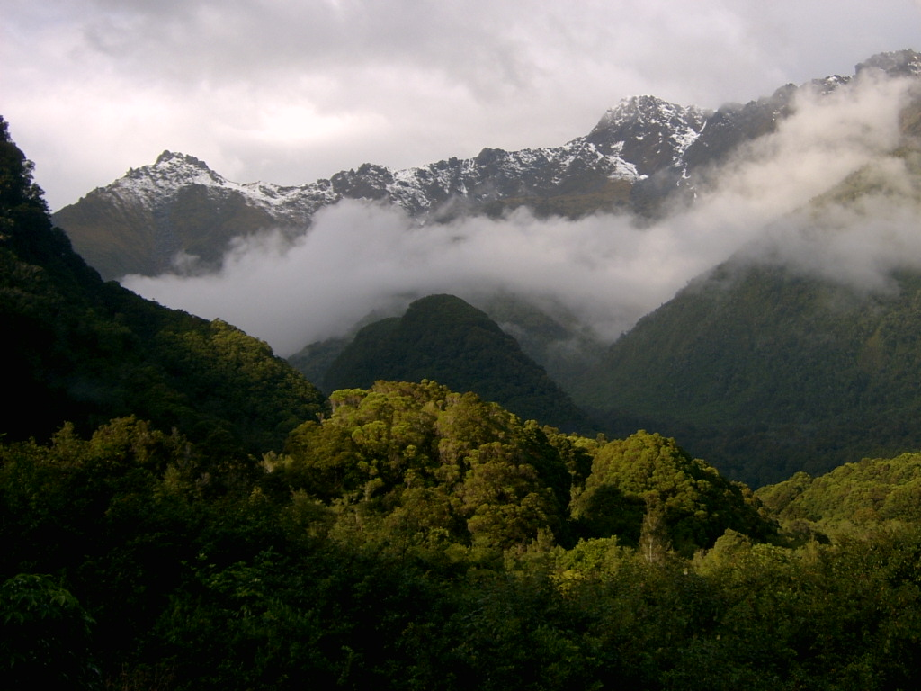
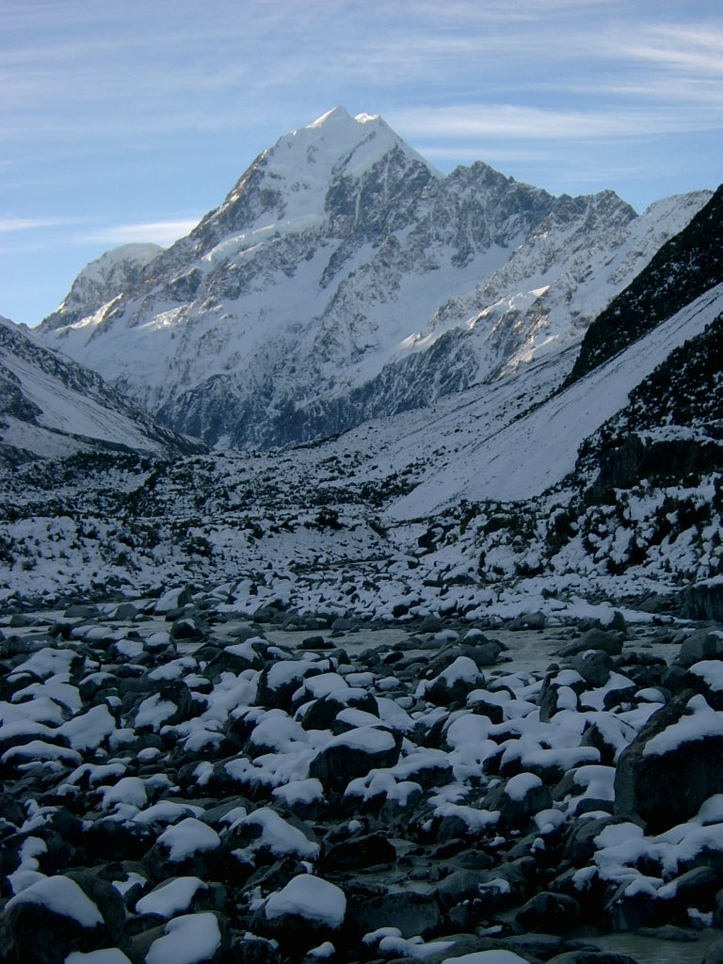
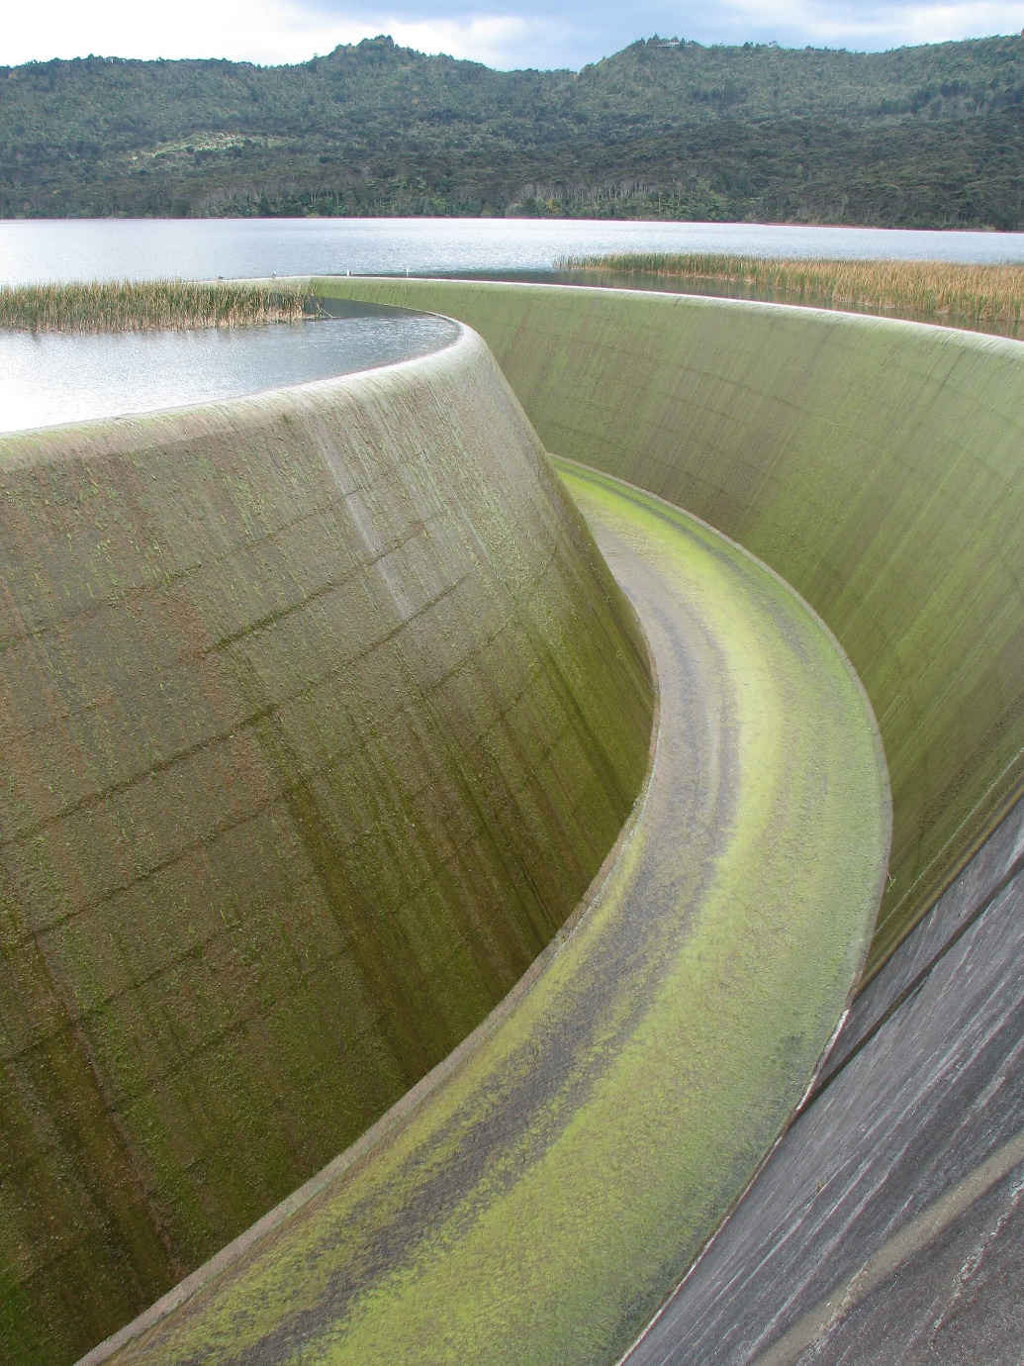
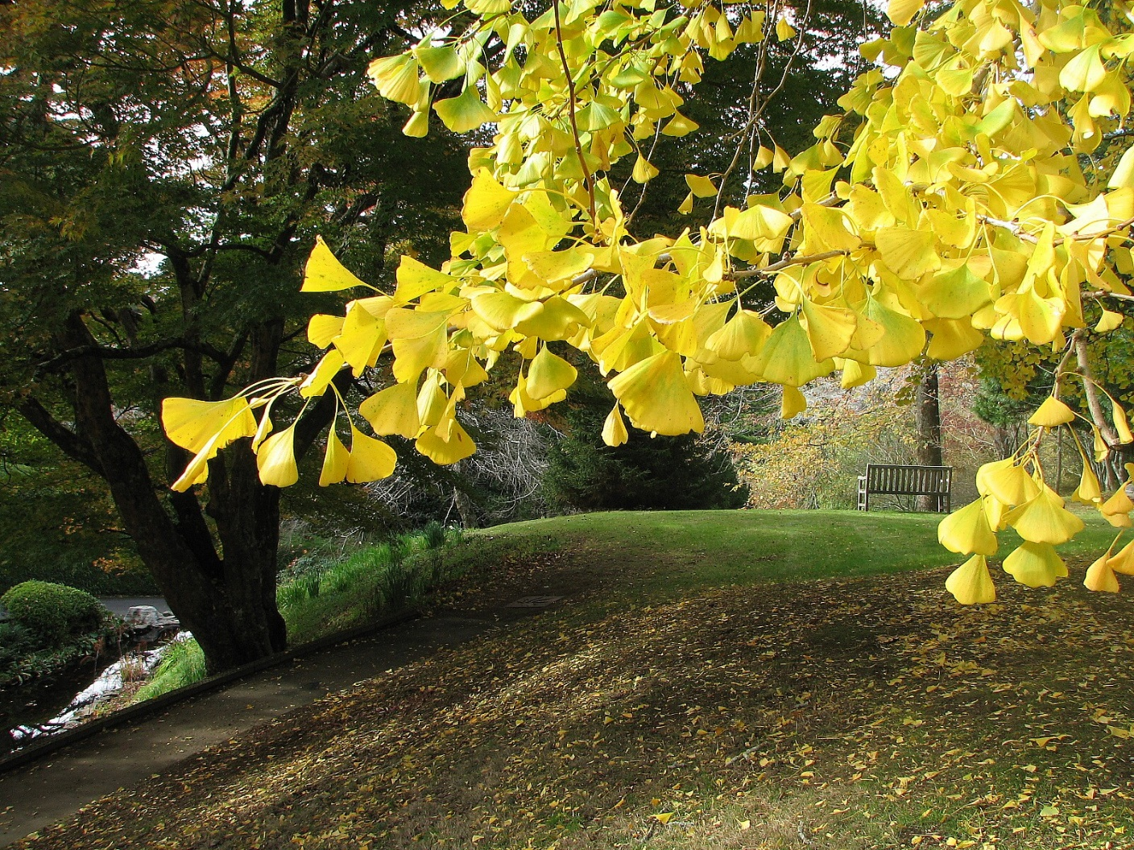
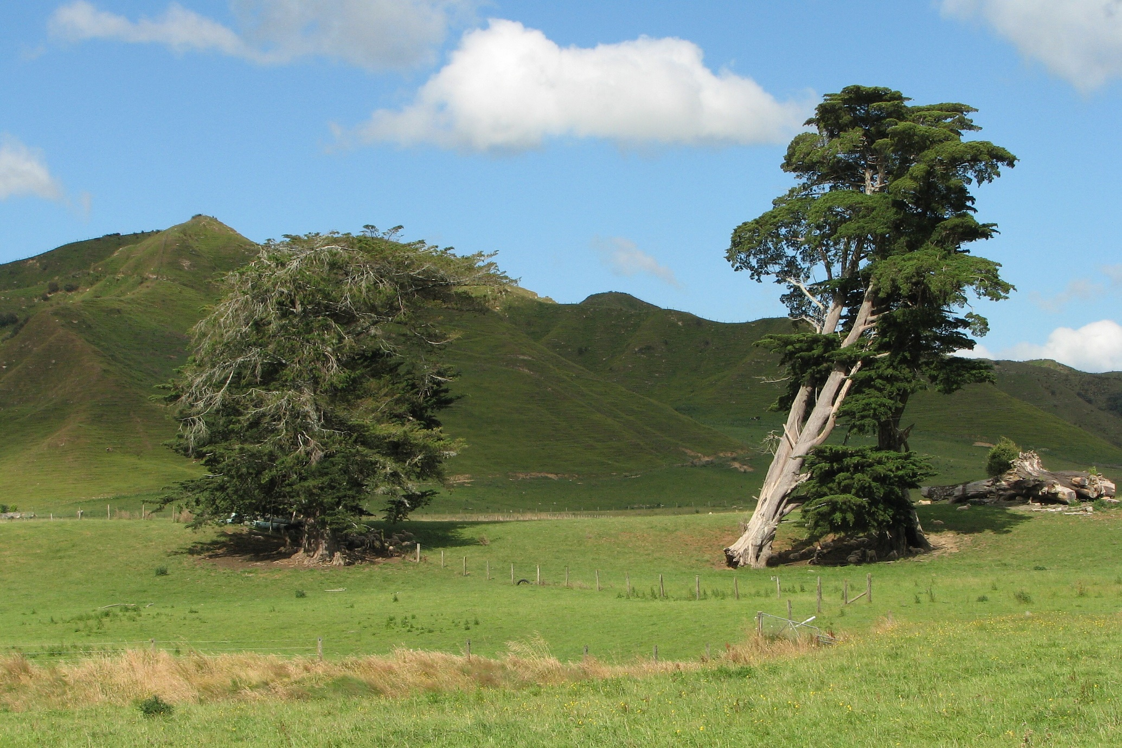
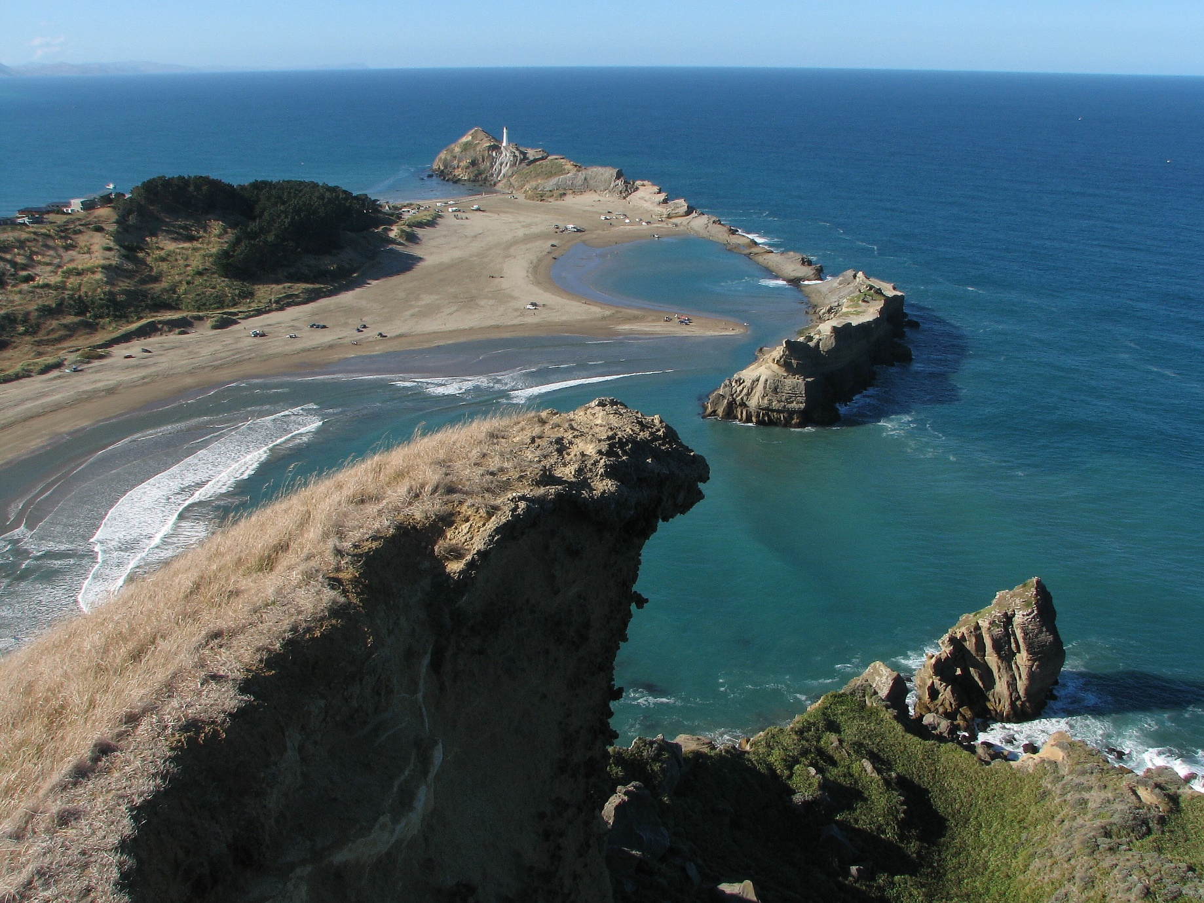
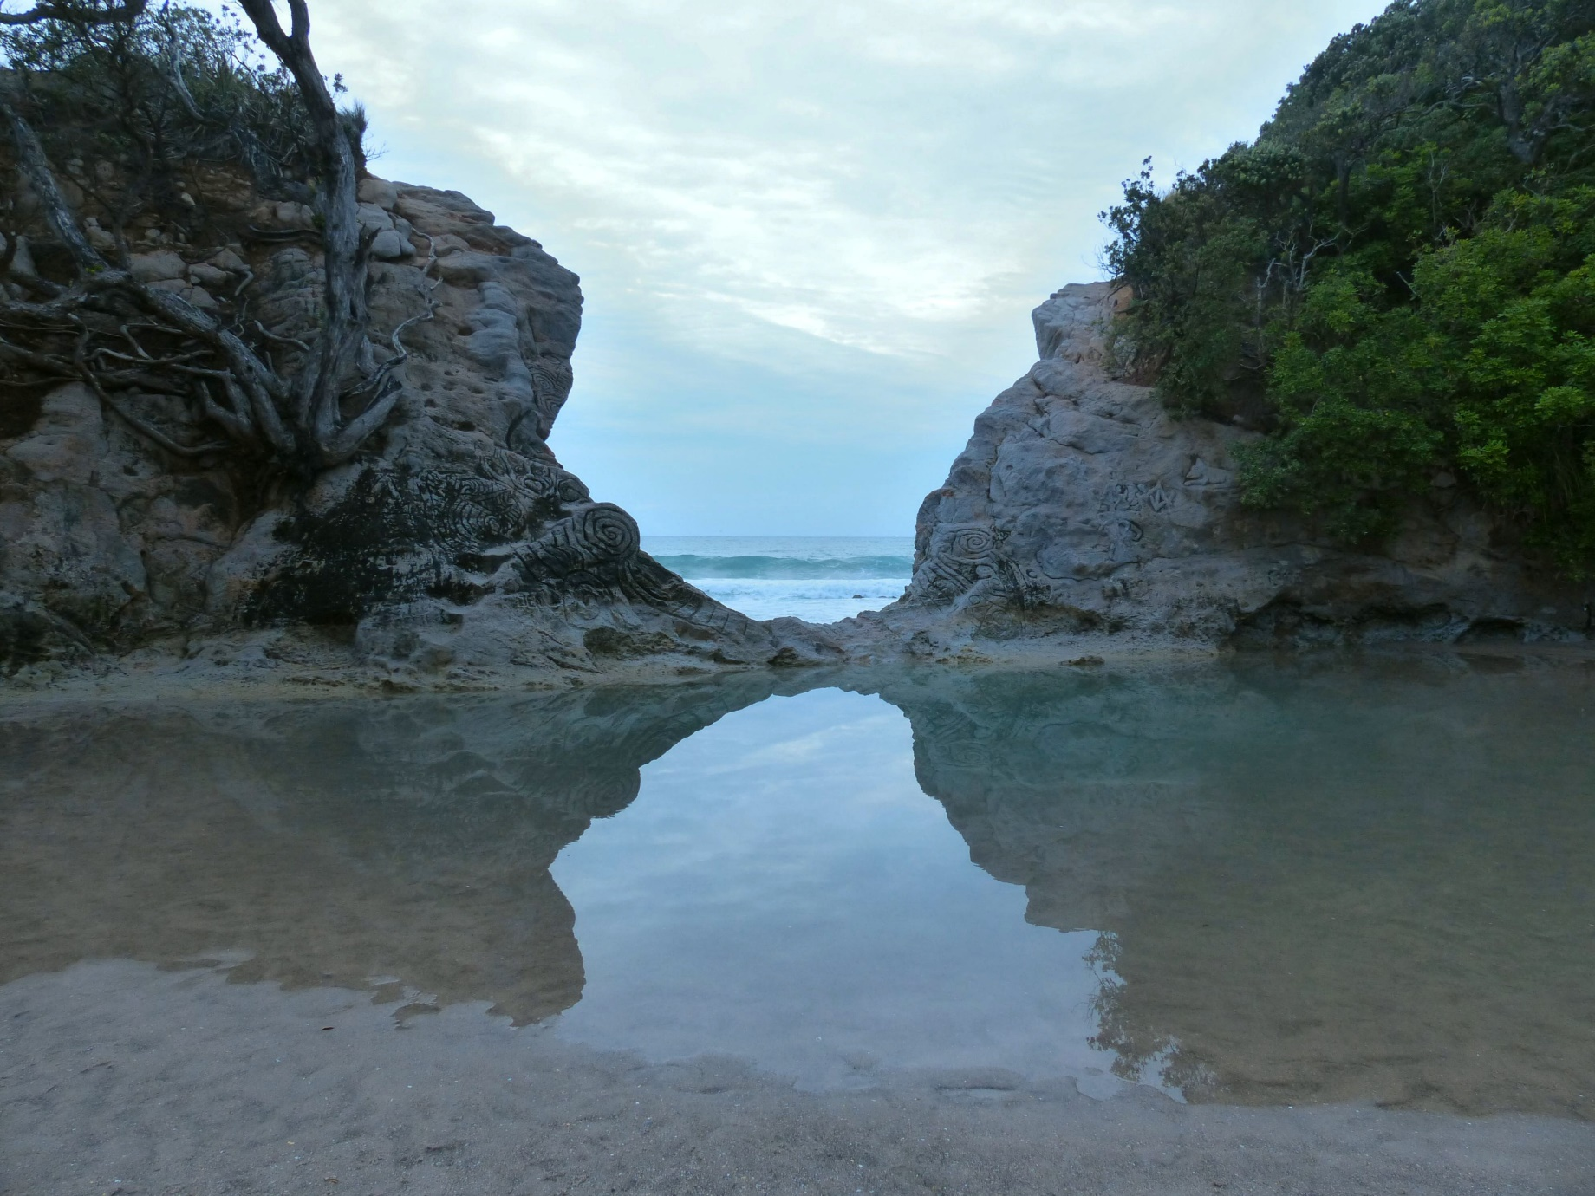
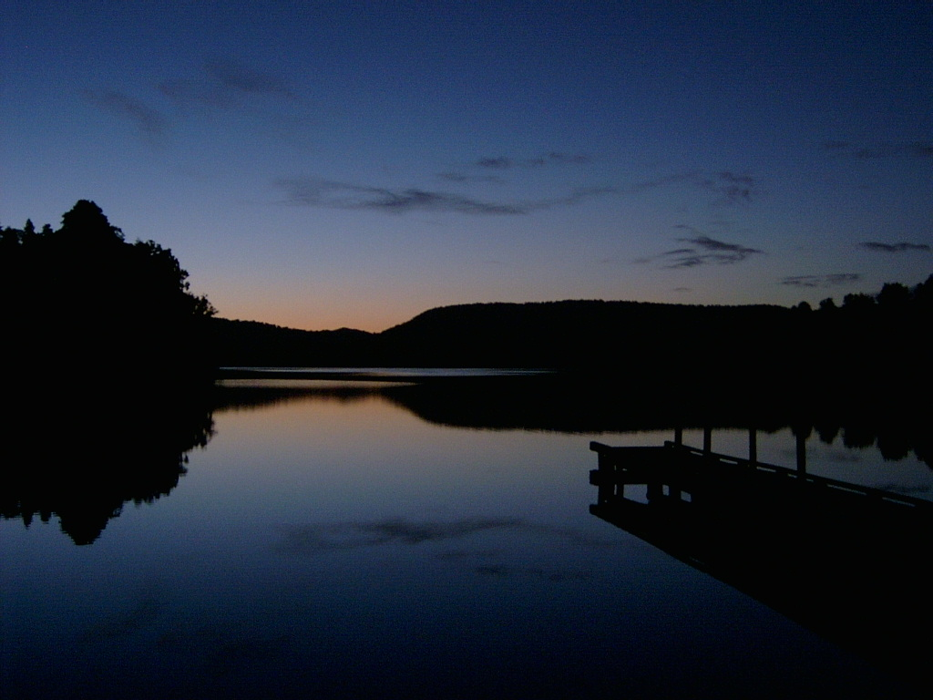
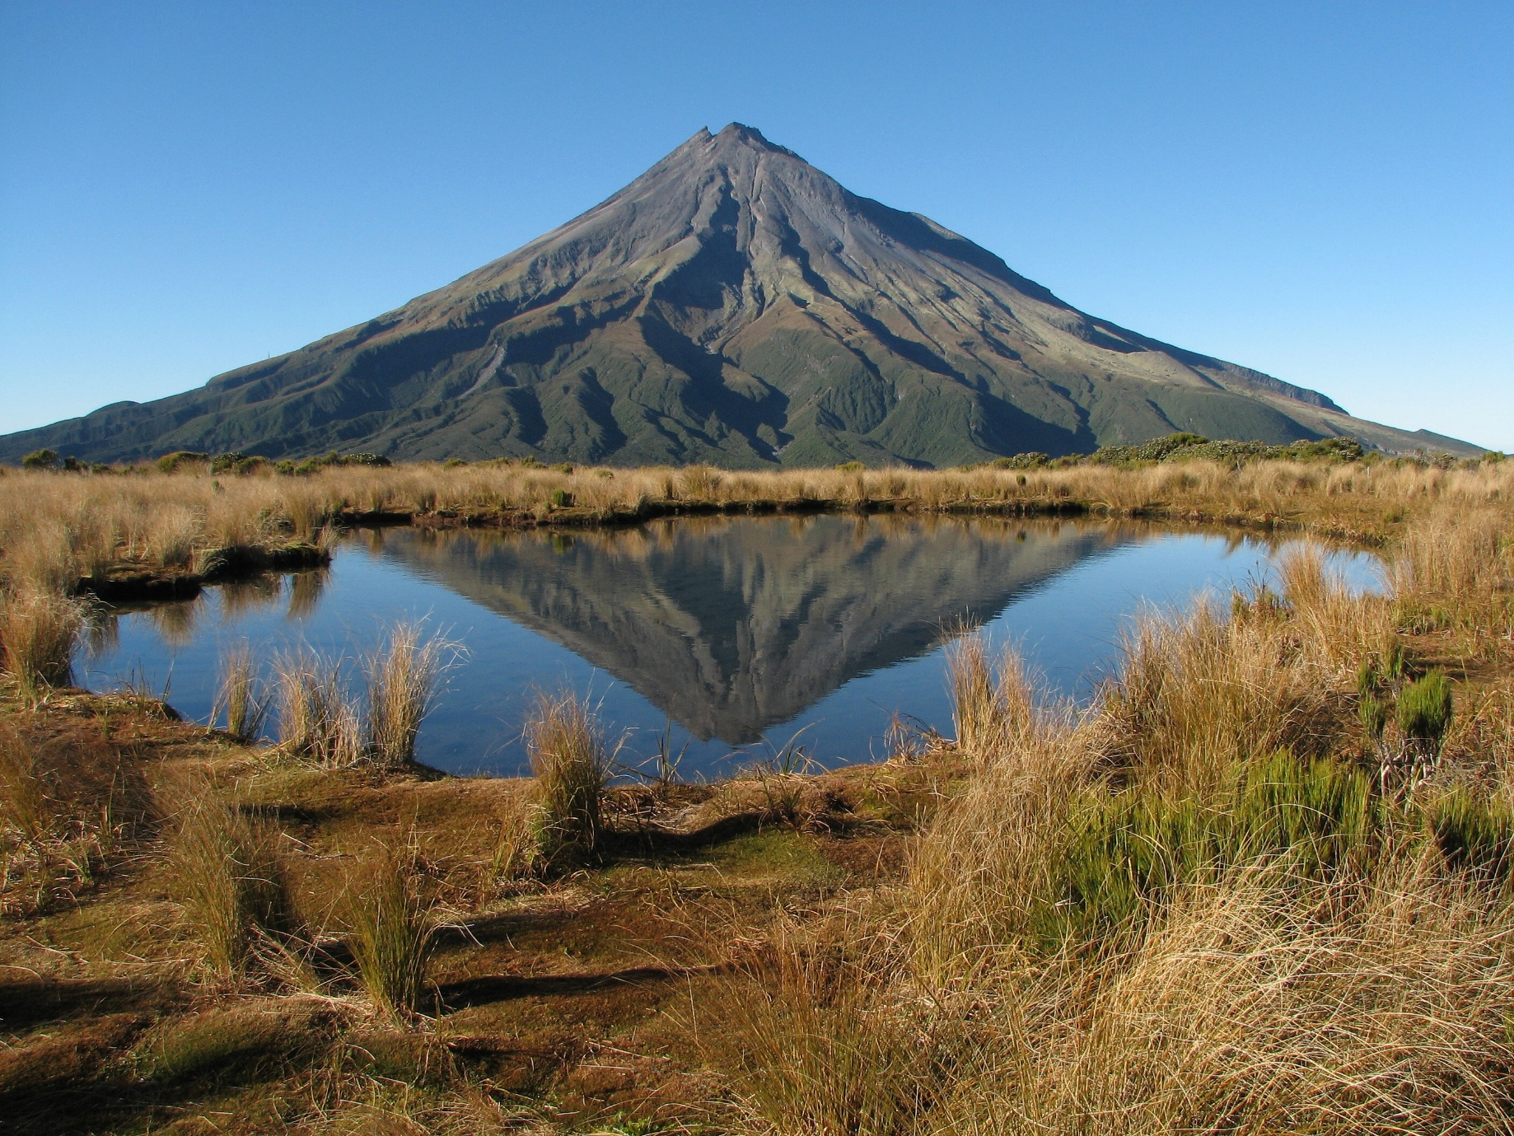
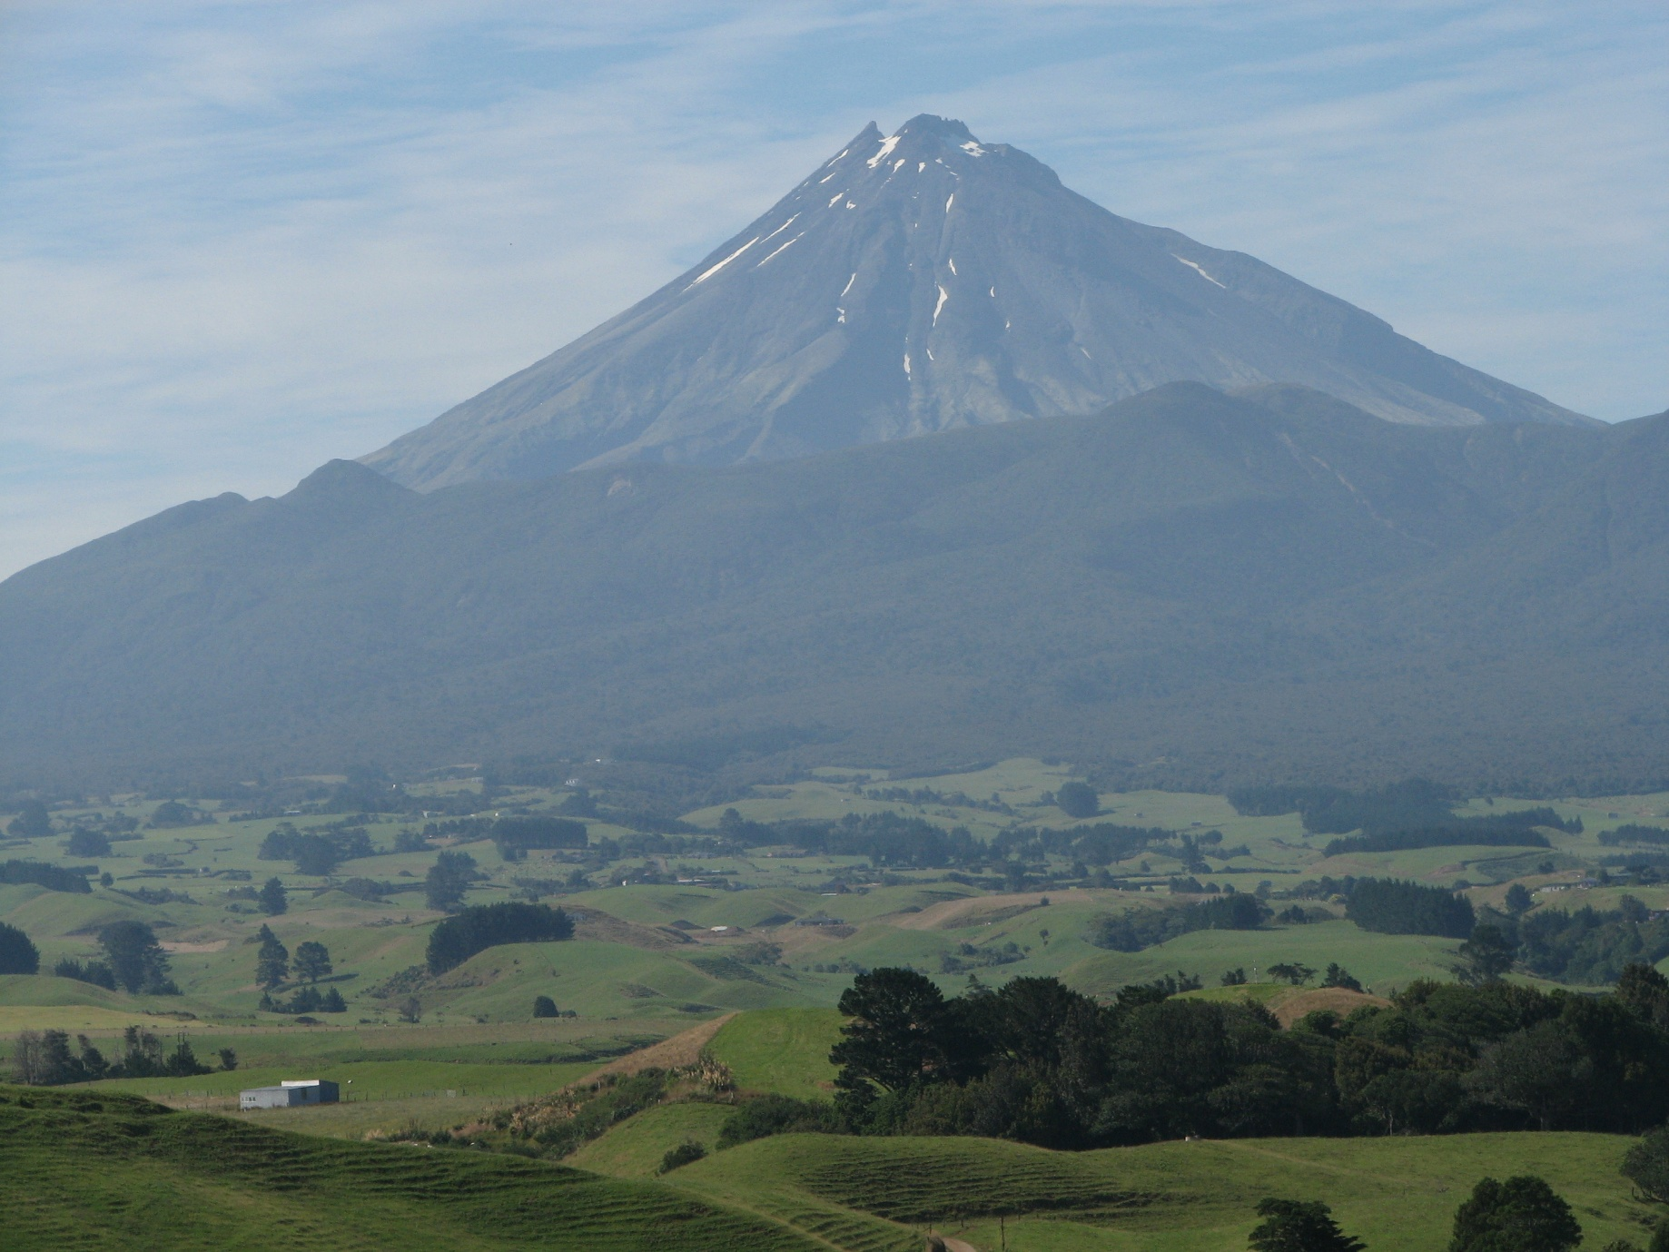
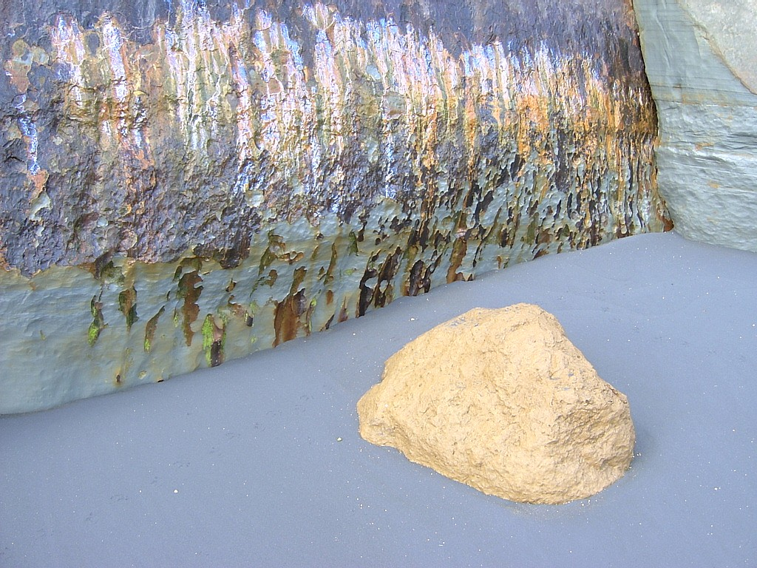
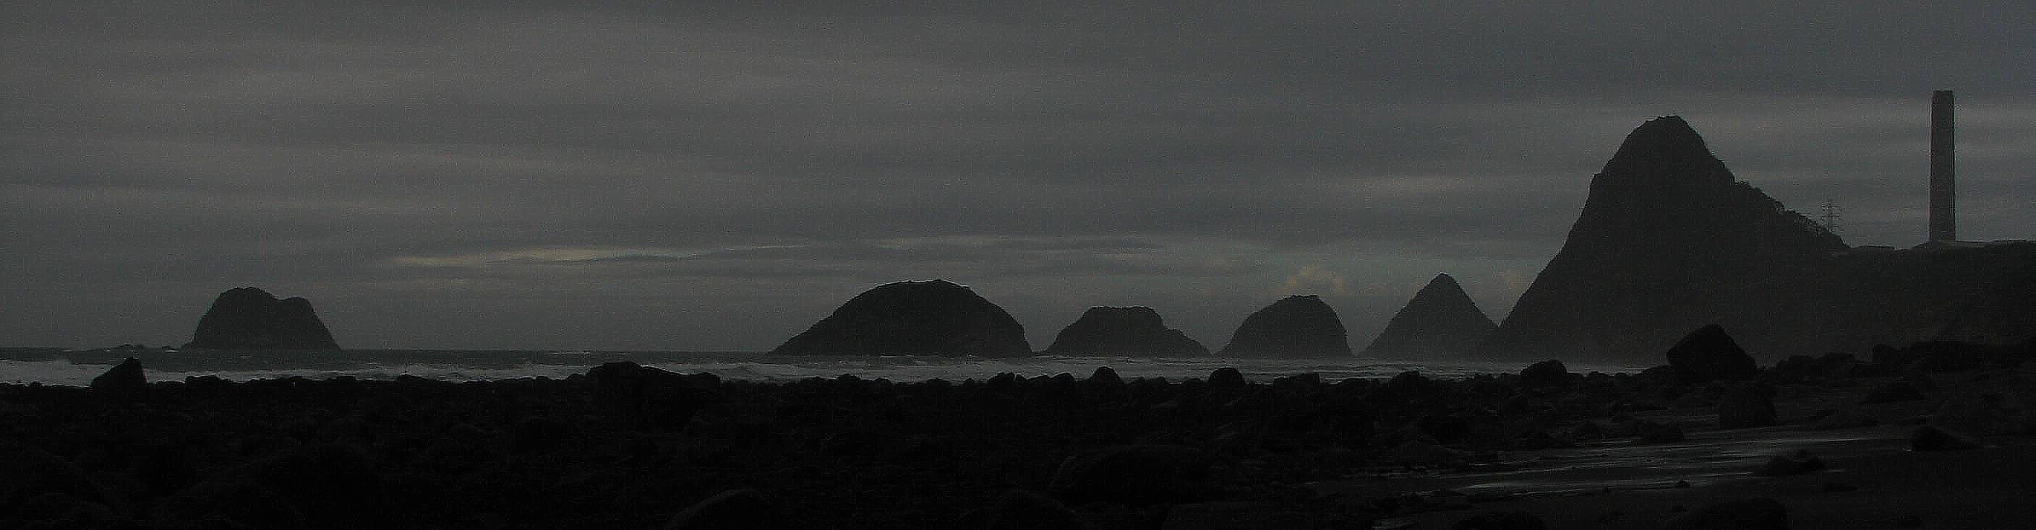
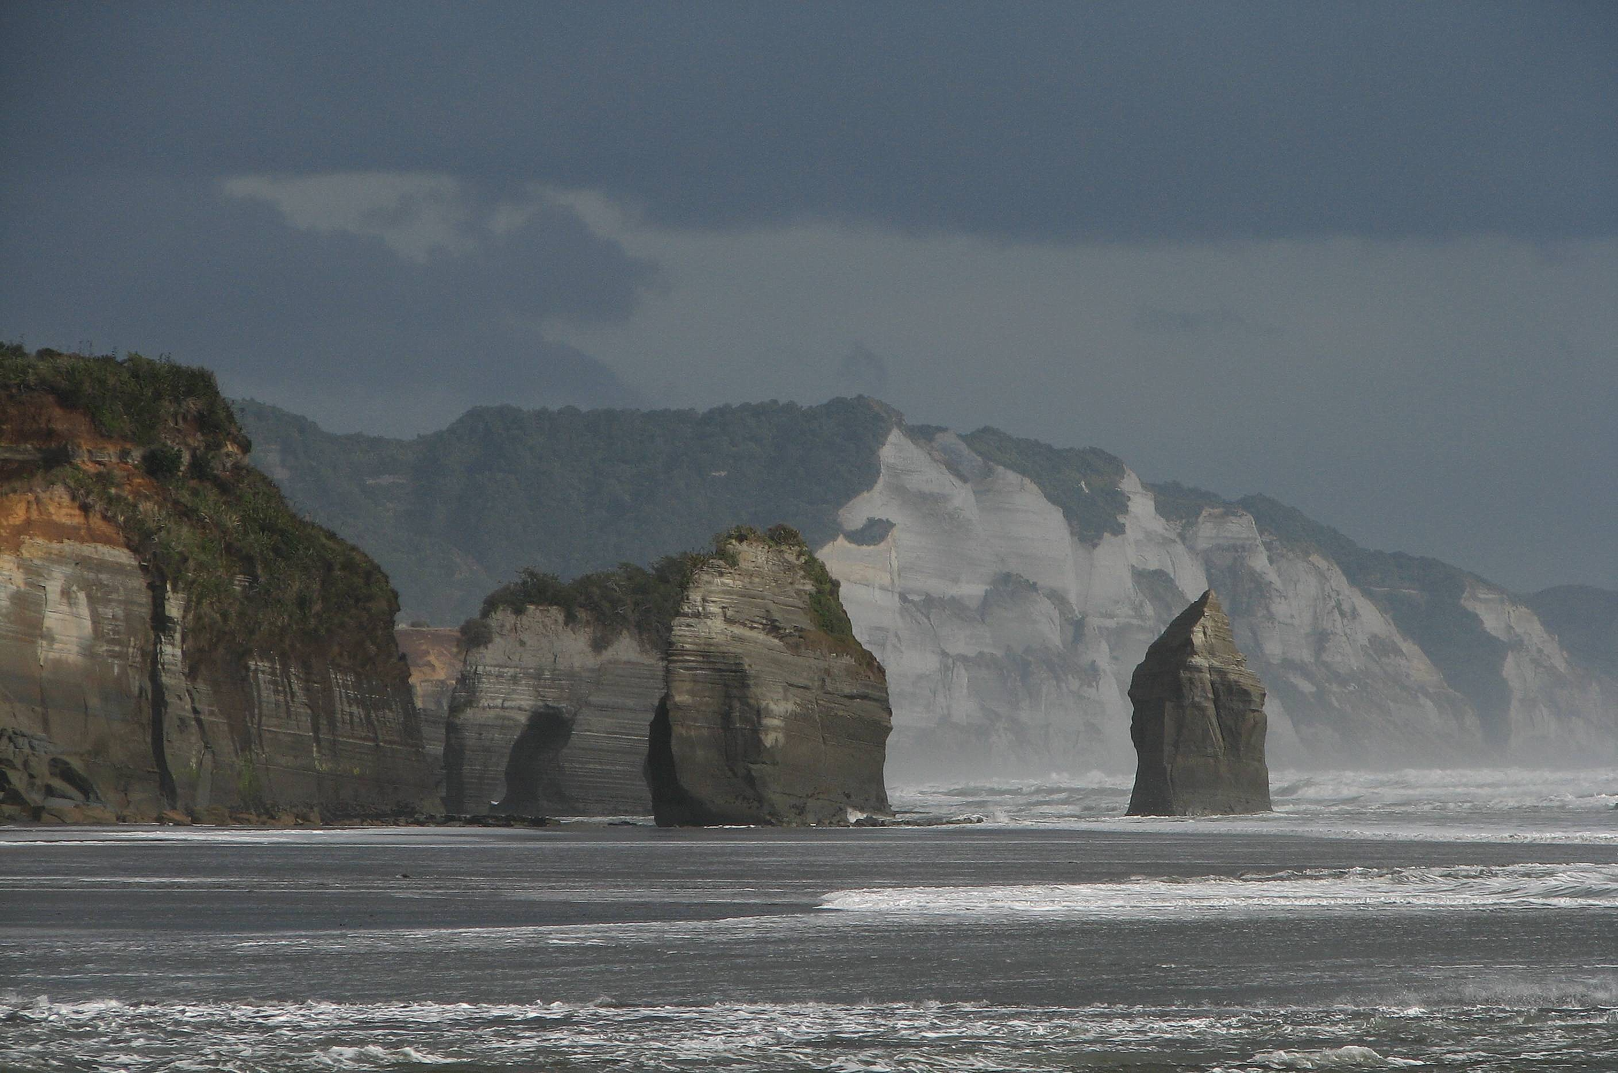
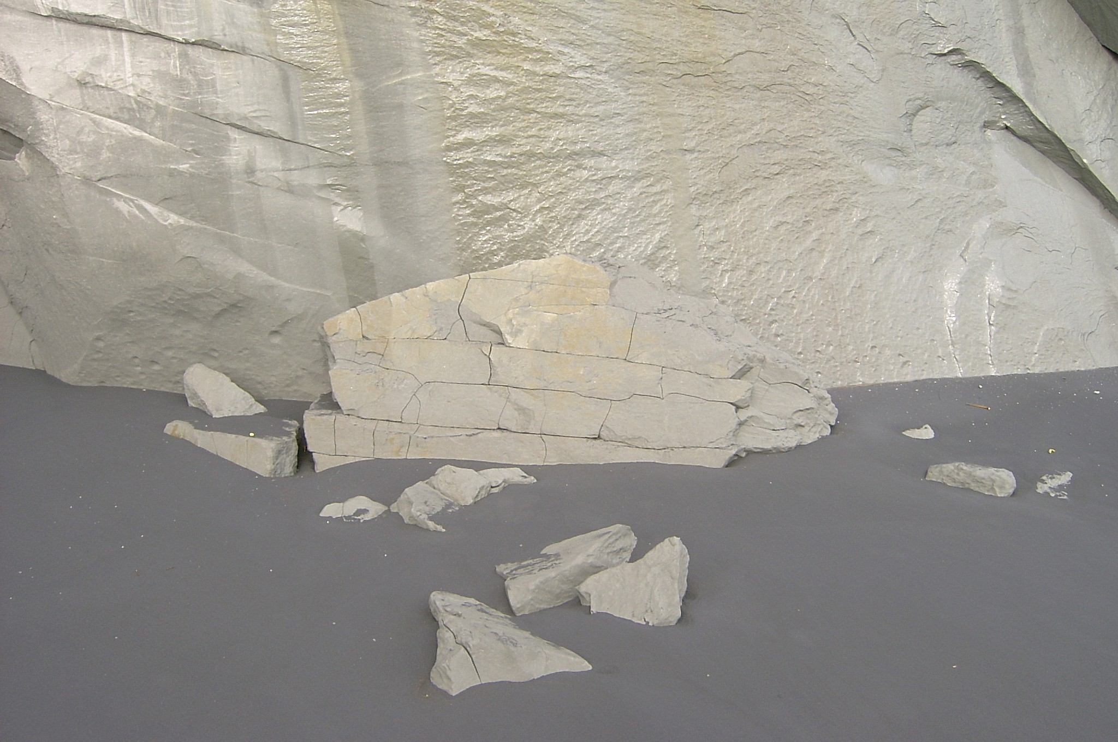
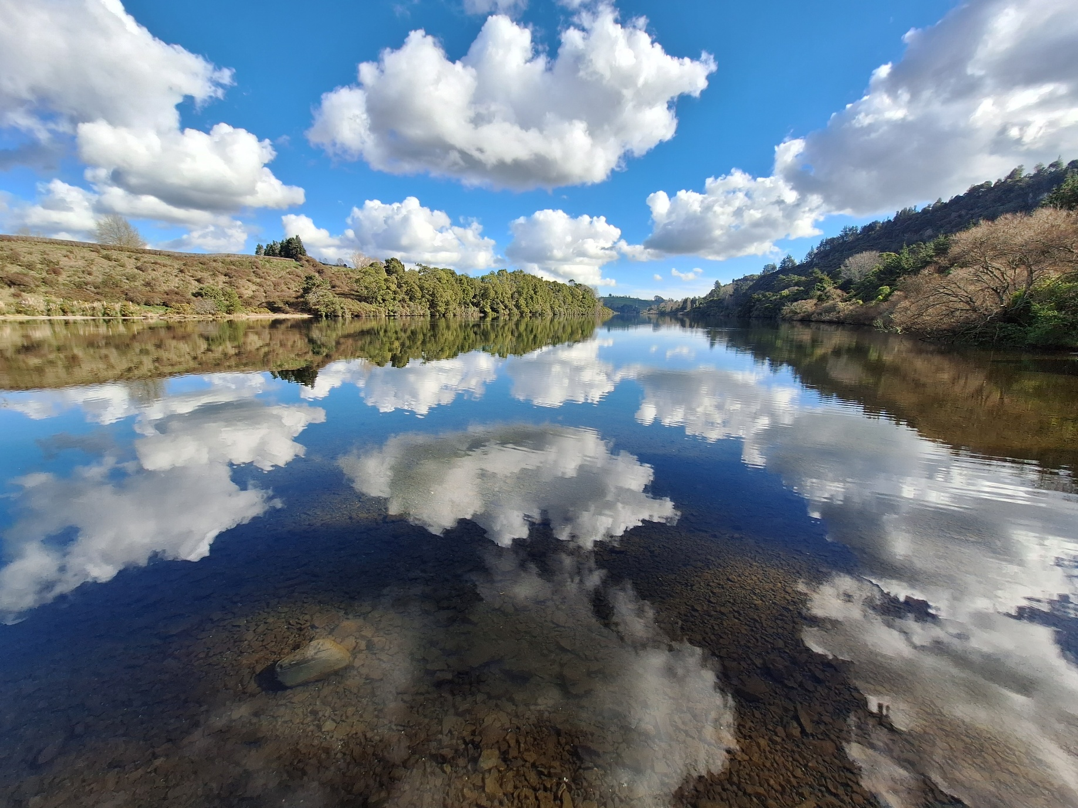
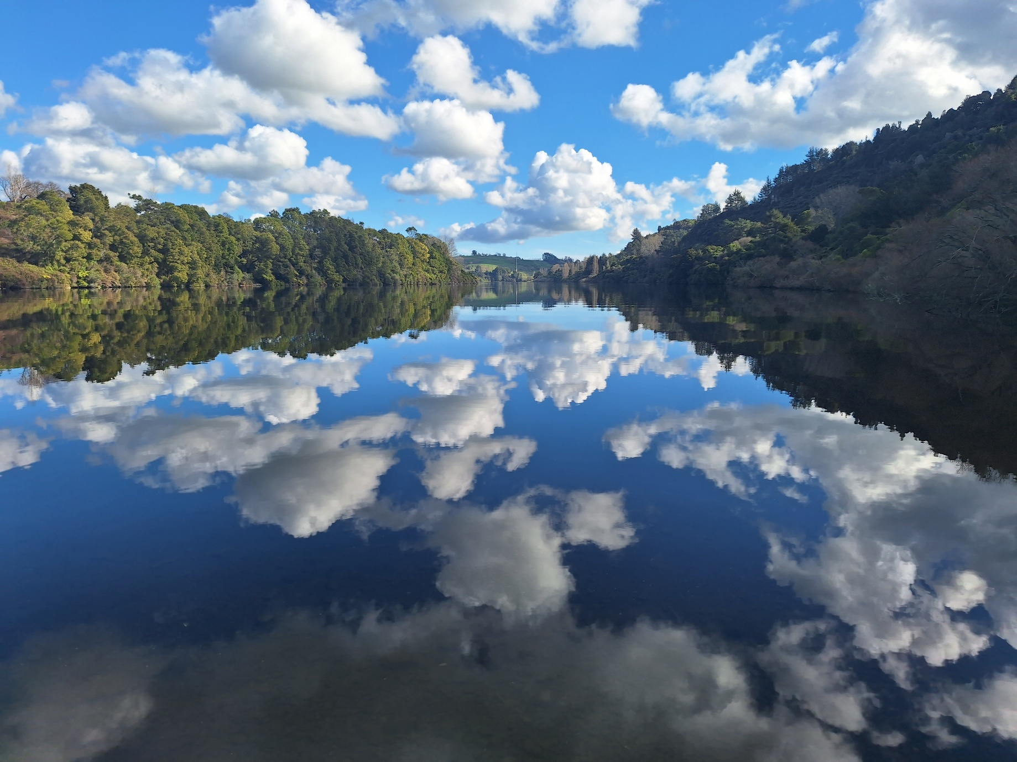
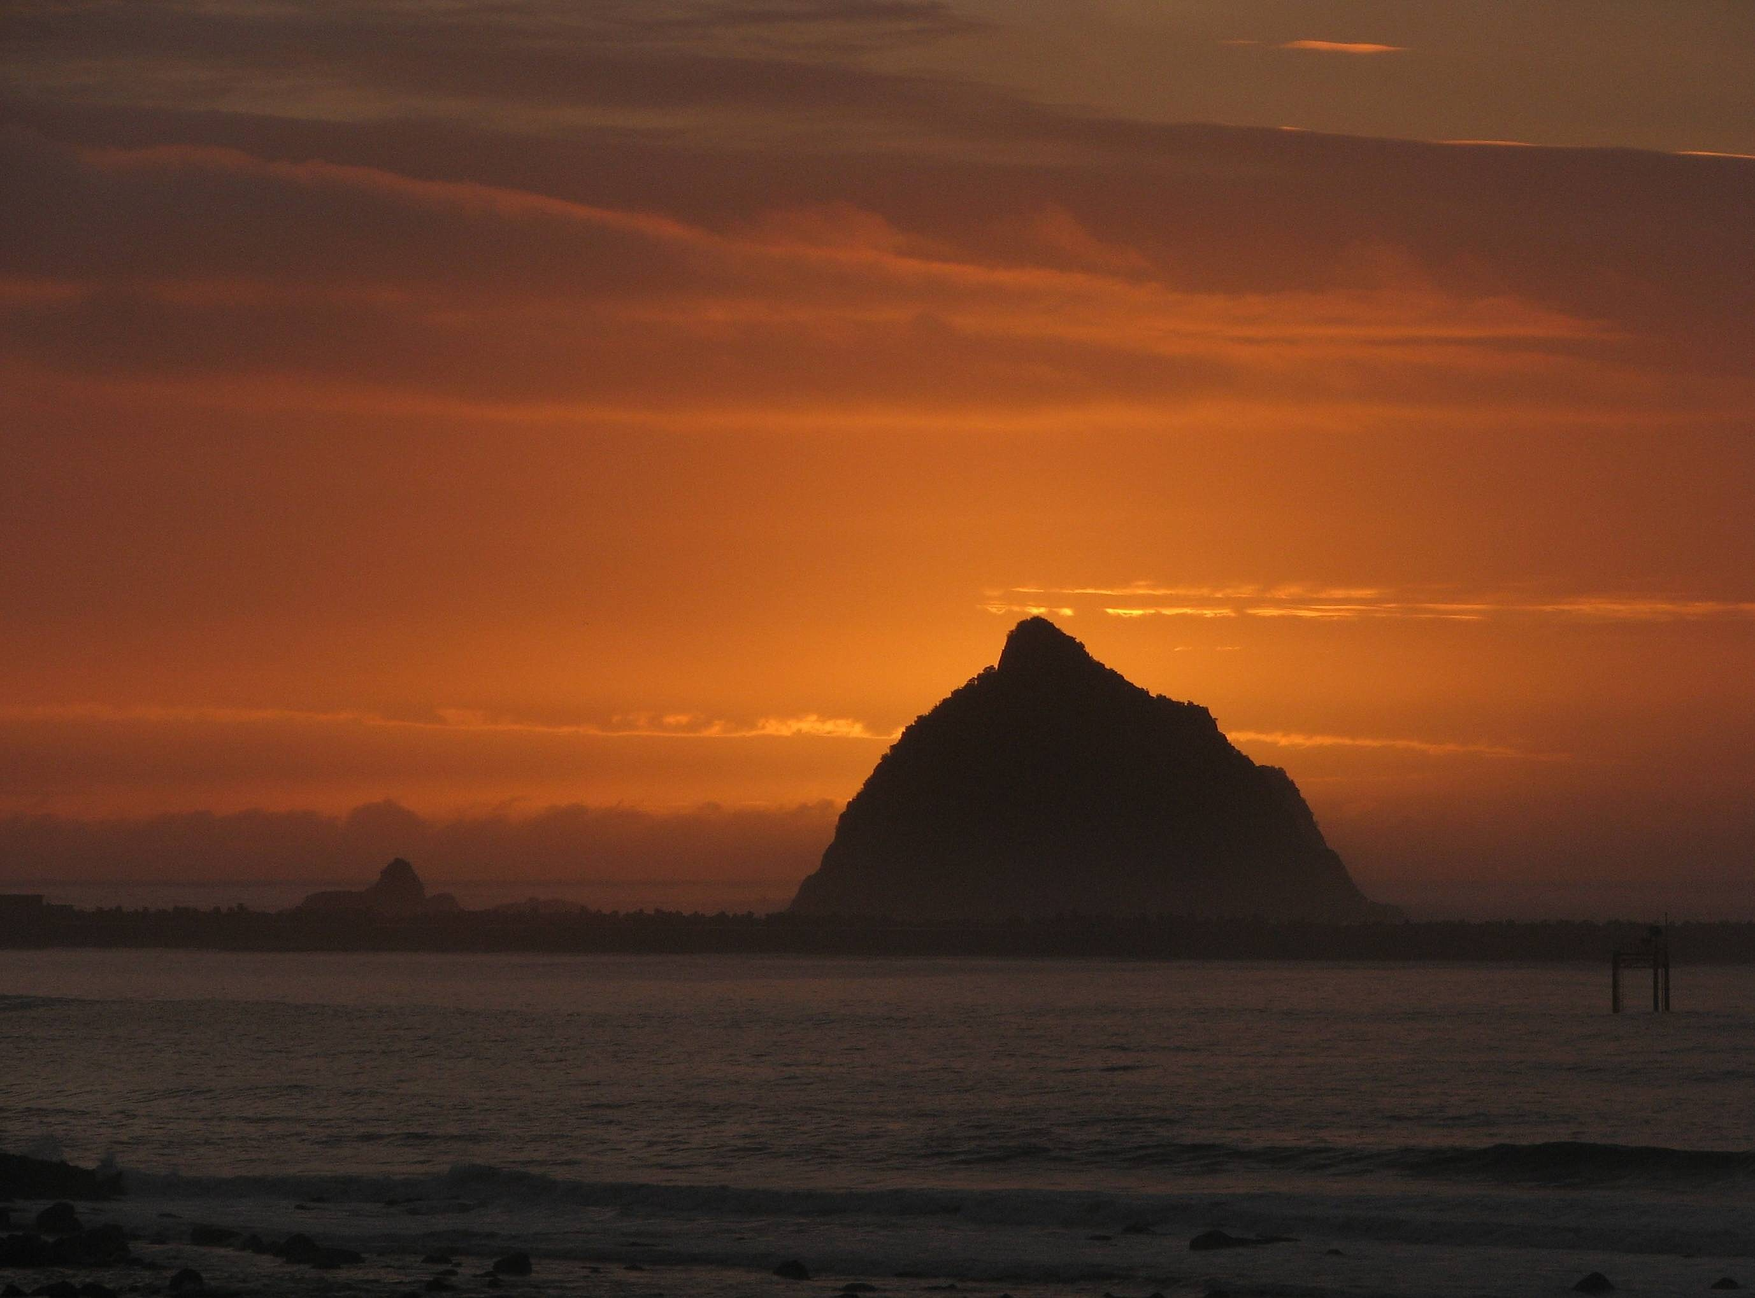

Ancient rainforests, rugged mountains and untamed coastlines…
A collection of photographs of New Zealand.

All photos by Alan Greenhead. More photography can be found at:
www.flickr.com/photos/alan_greenhead www.flickriver.com/photos/alan_greenhead/

