TARANAKI
The Lonely Mountain

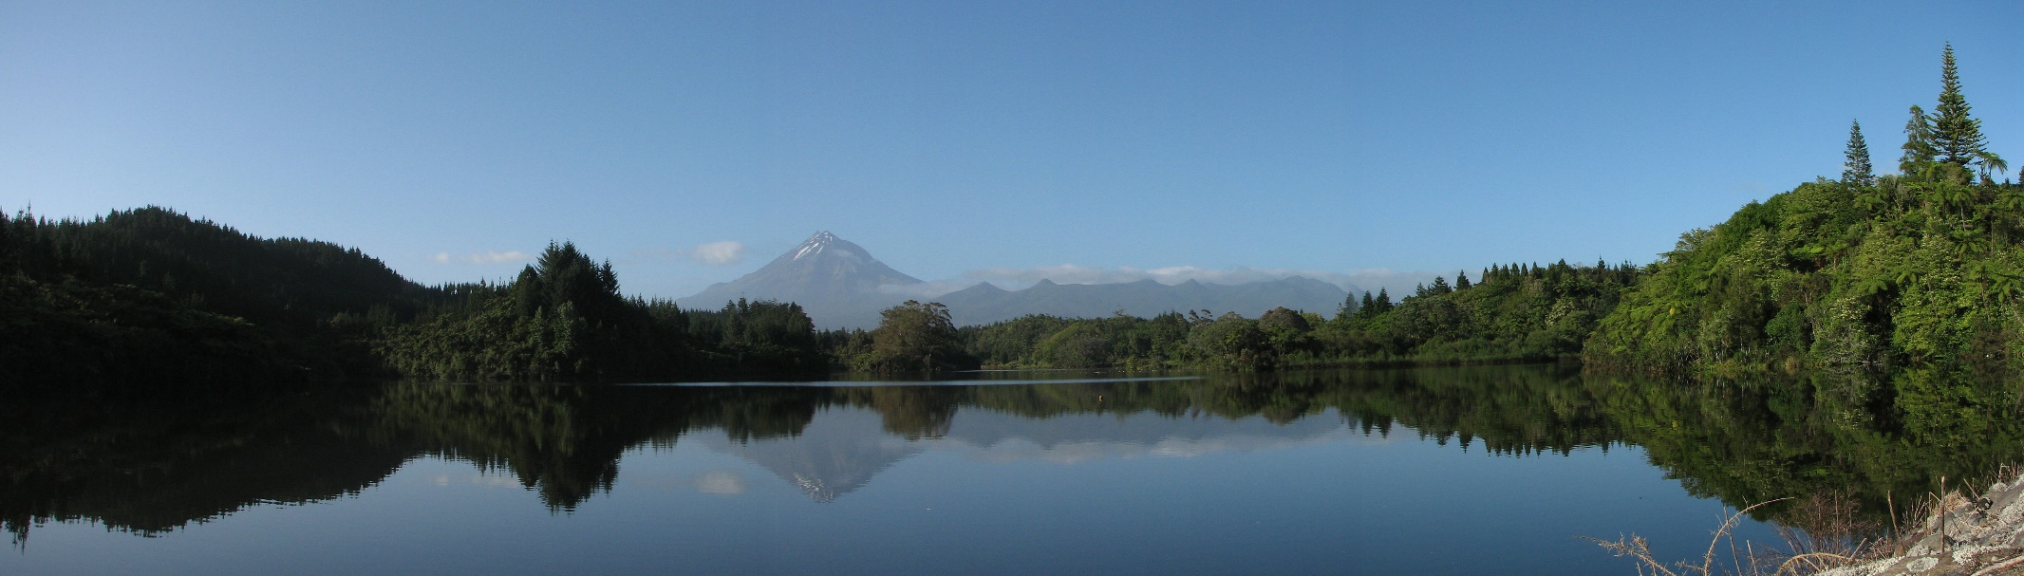

A collection of photographs of Mount Taranaki, New Zealand.

Published by A. Greenhead, New Zealand, 2023
Copyright © Alan Greenhead, 2023 All rights reserved.
www.planetbob.yolasite.com agreenhead2@gmail.com

Locations (in photo order):
(cover) Lake Mangamahoe
1 - 3 Views from Pouakai Ranges
4 South Taranaki
5 Near Oakura
6 Lake Ratapiko
7 Near Tariki
8 - 10 Pouakai tarns
11 Road to Dawson Falls
12 Last light, Pouakai Ranges
13 Sunset, near Hawera

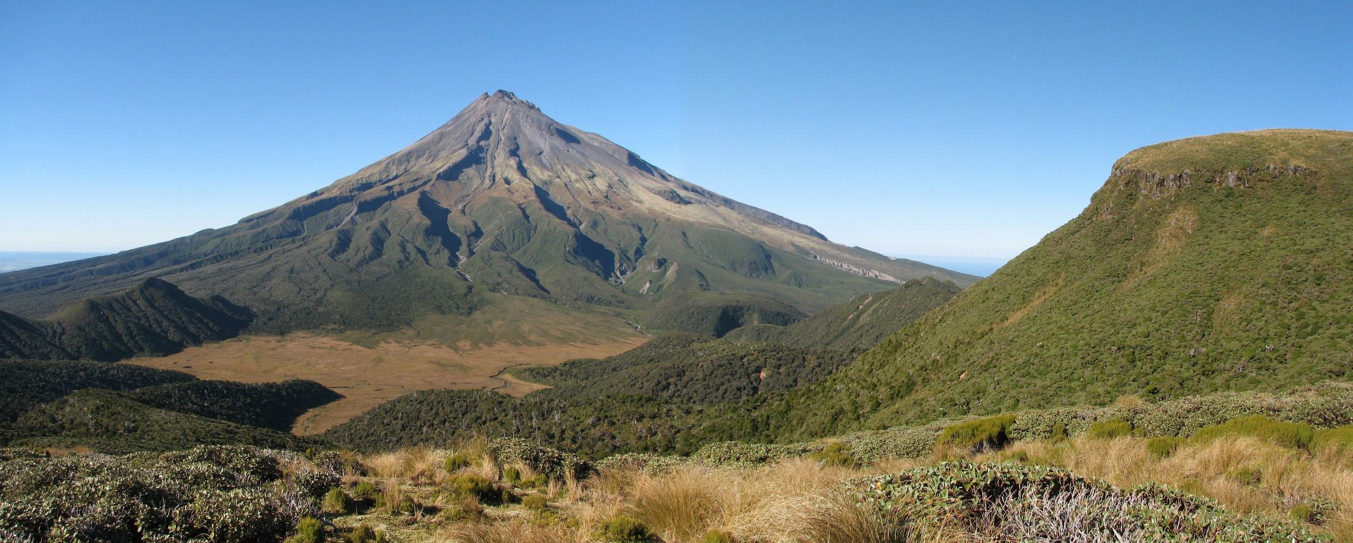
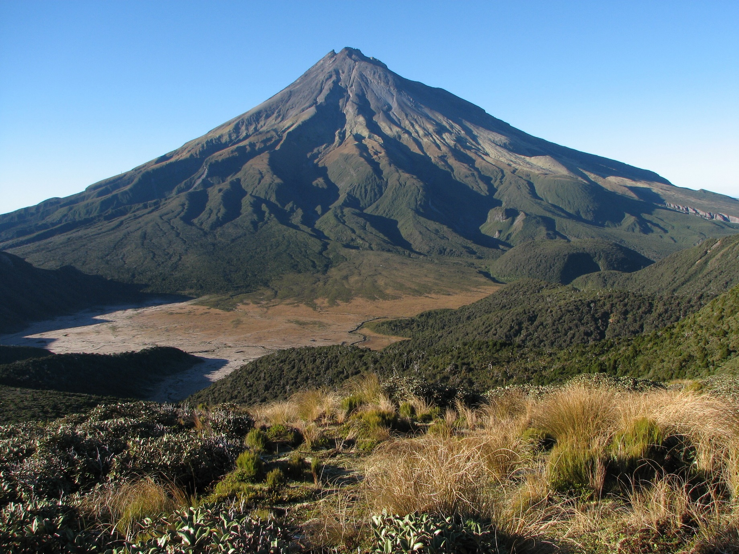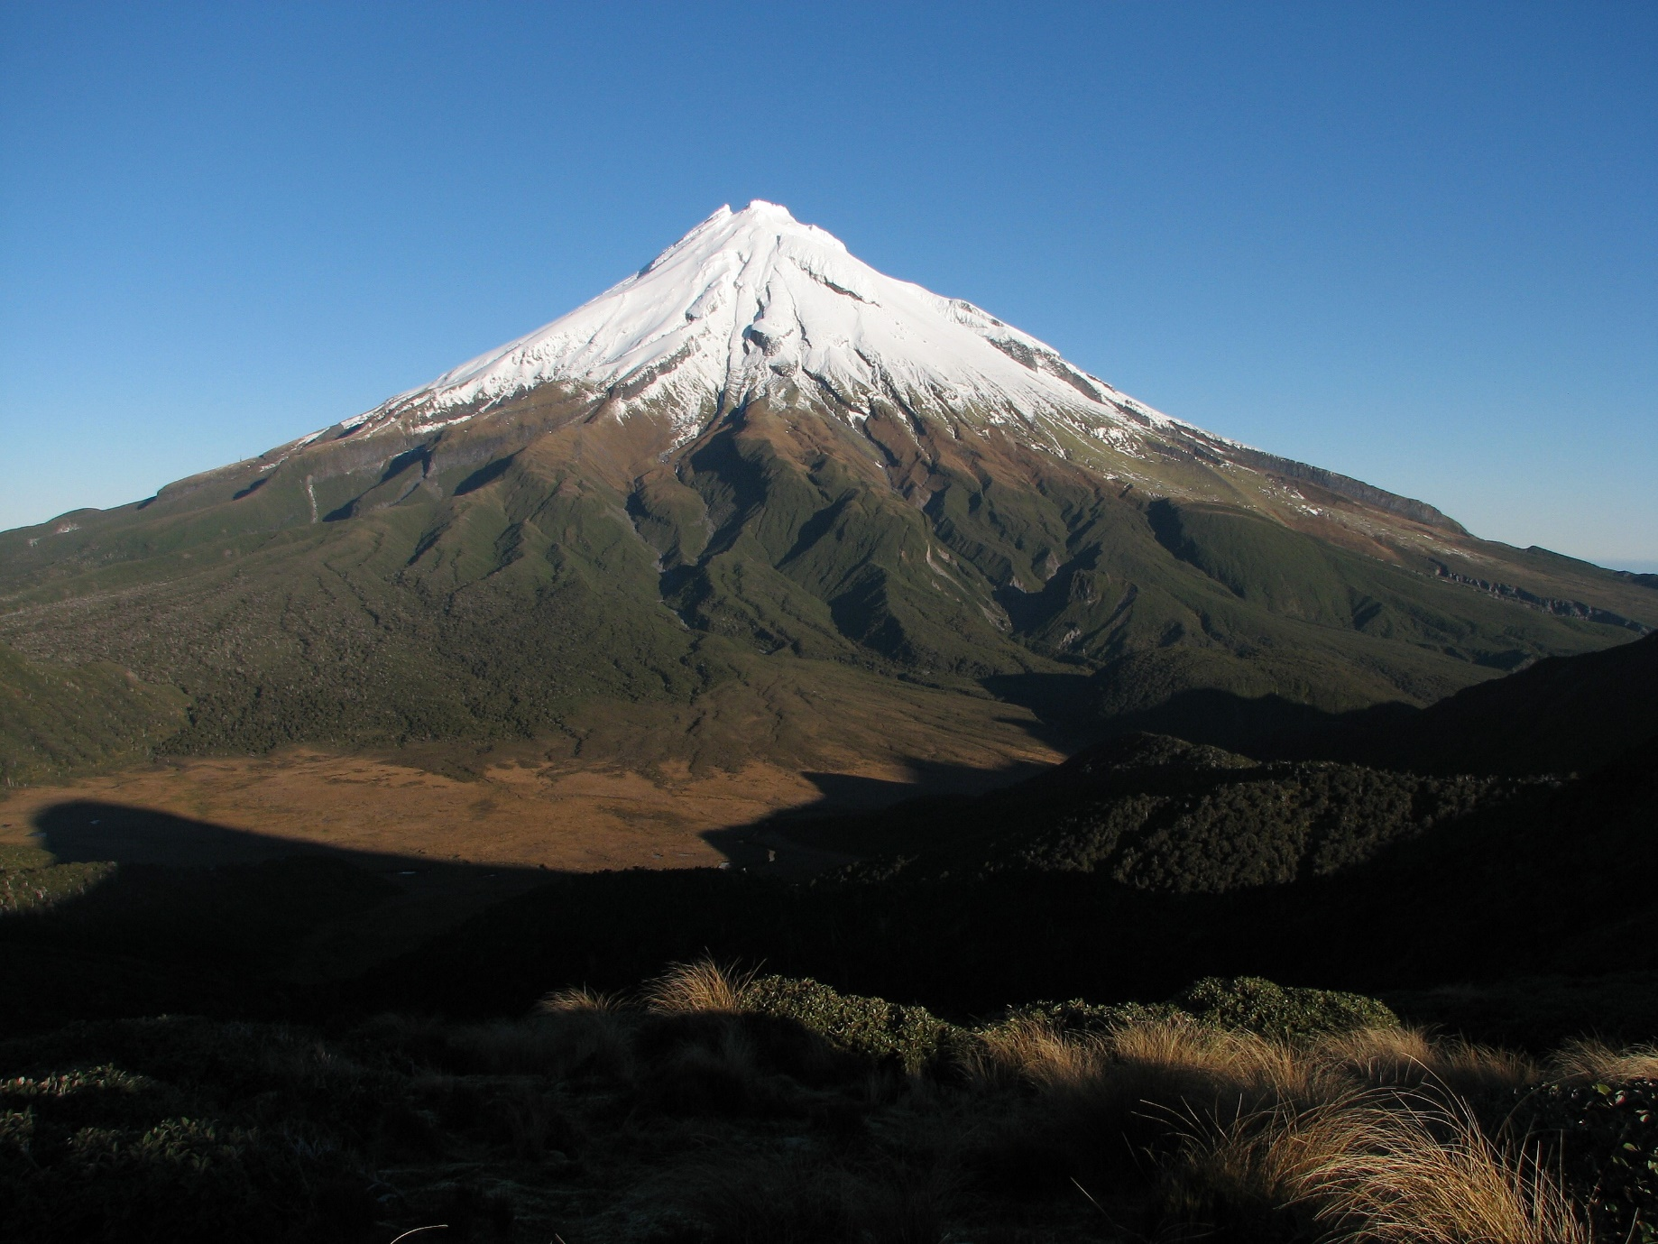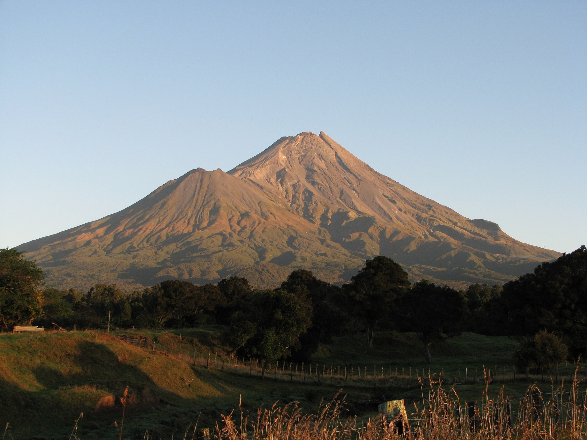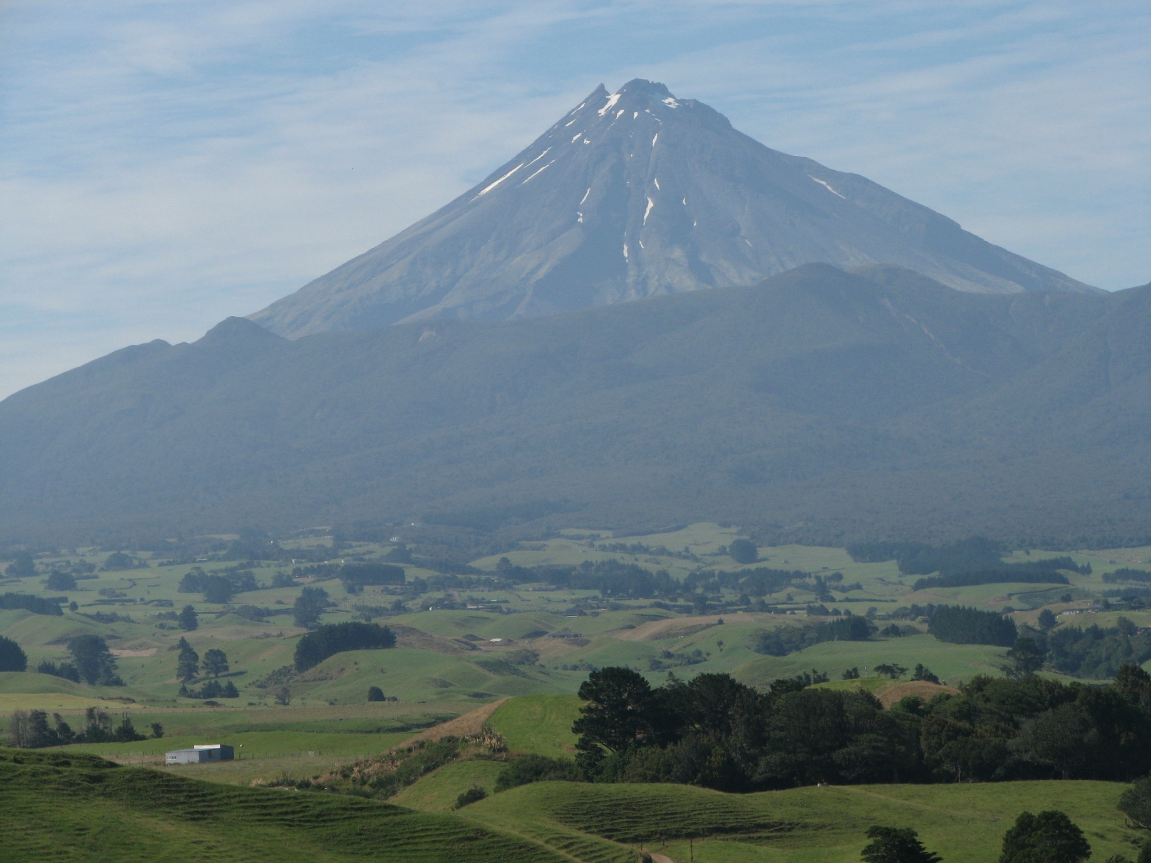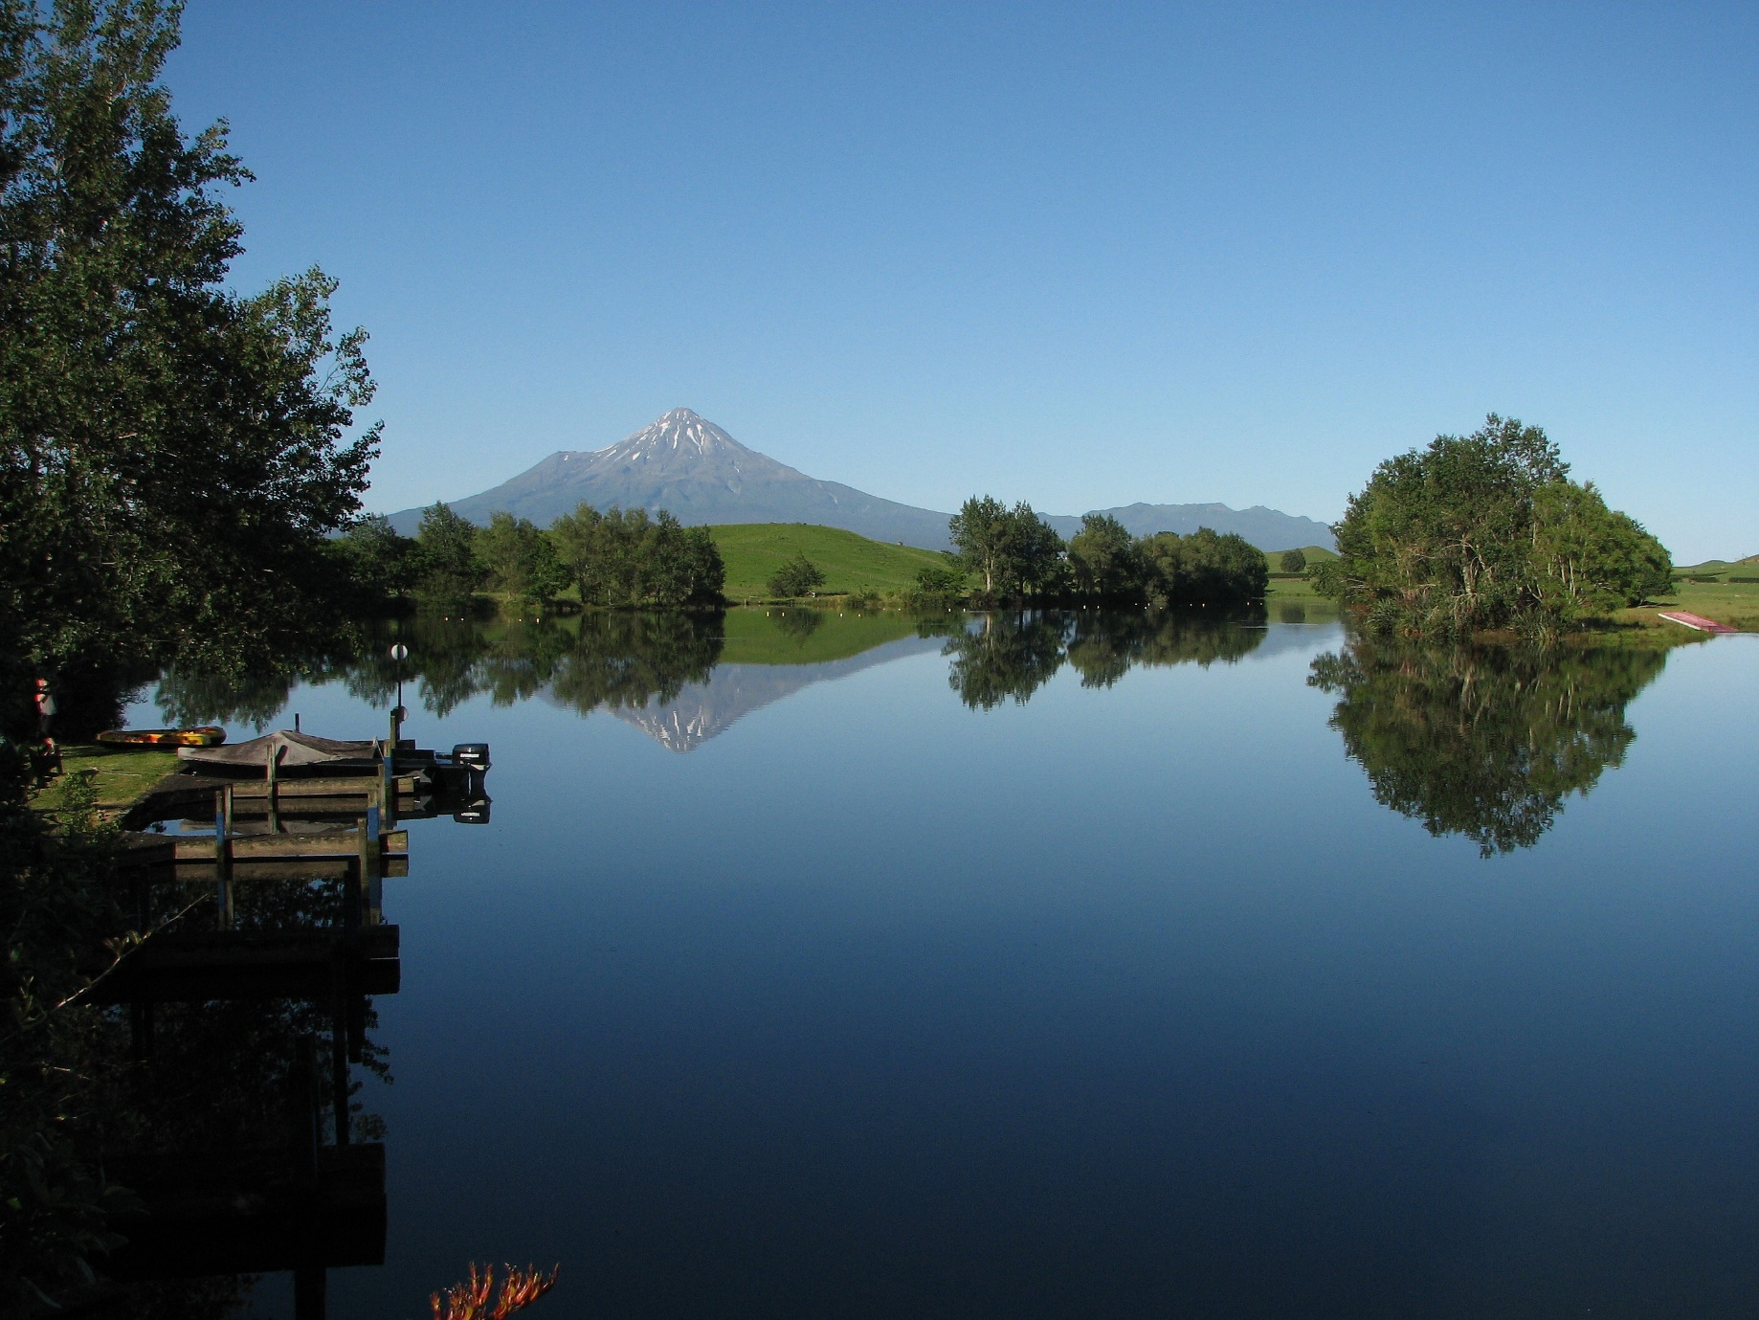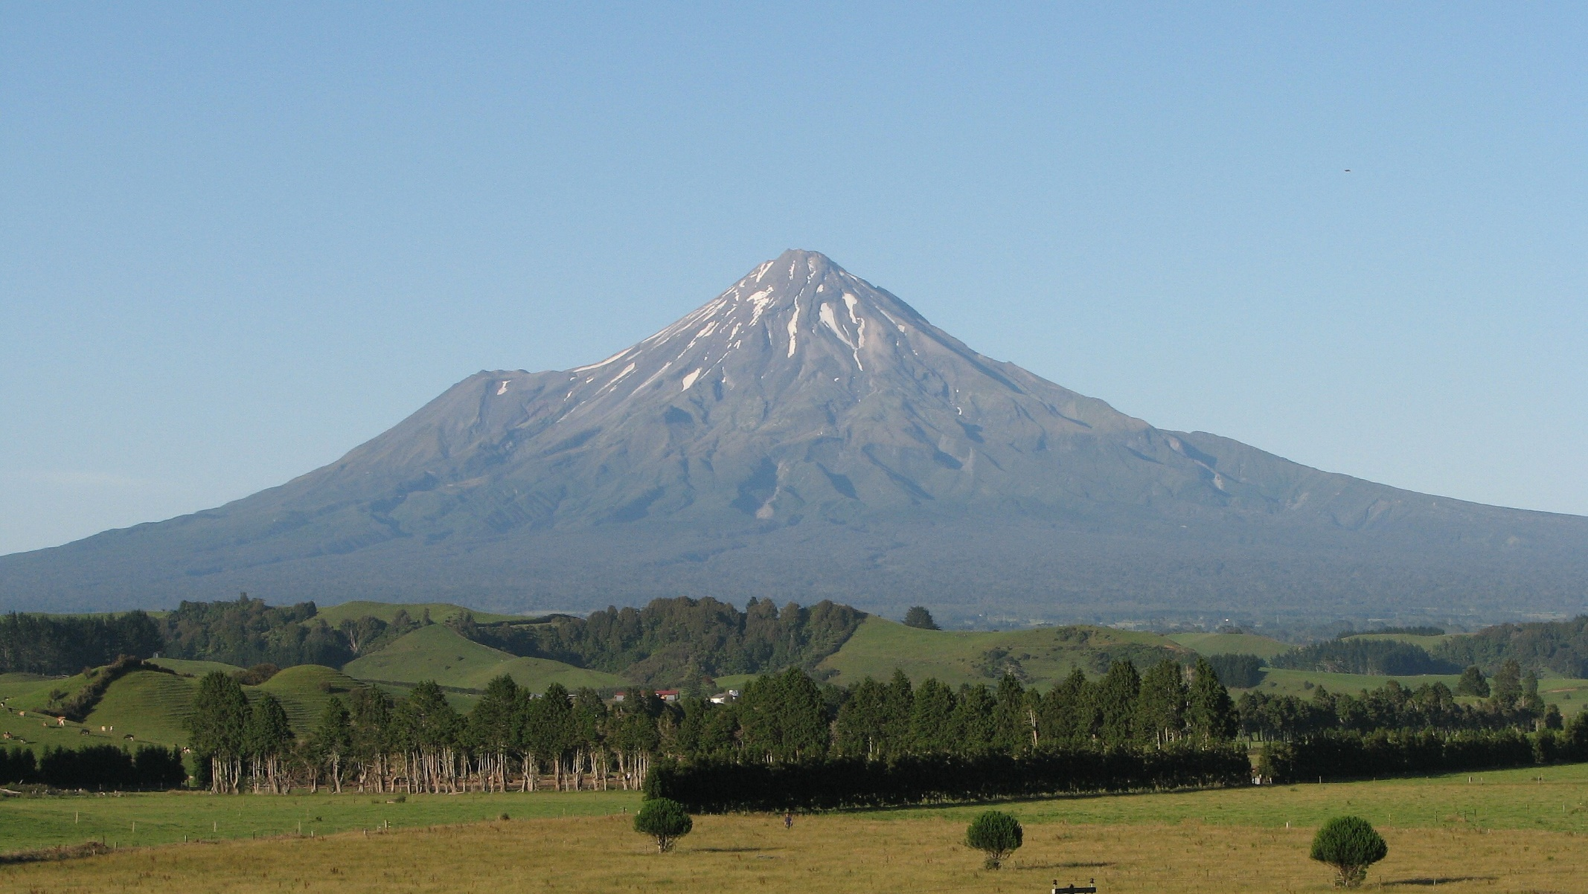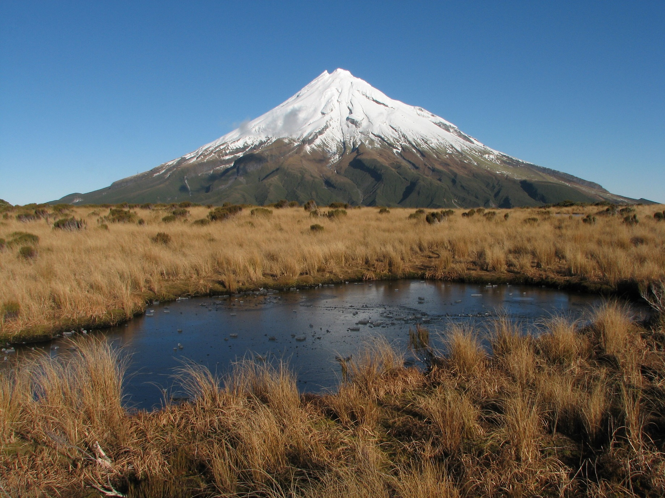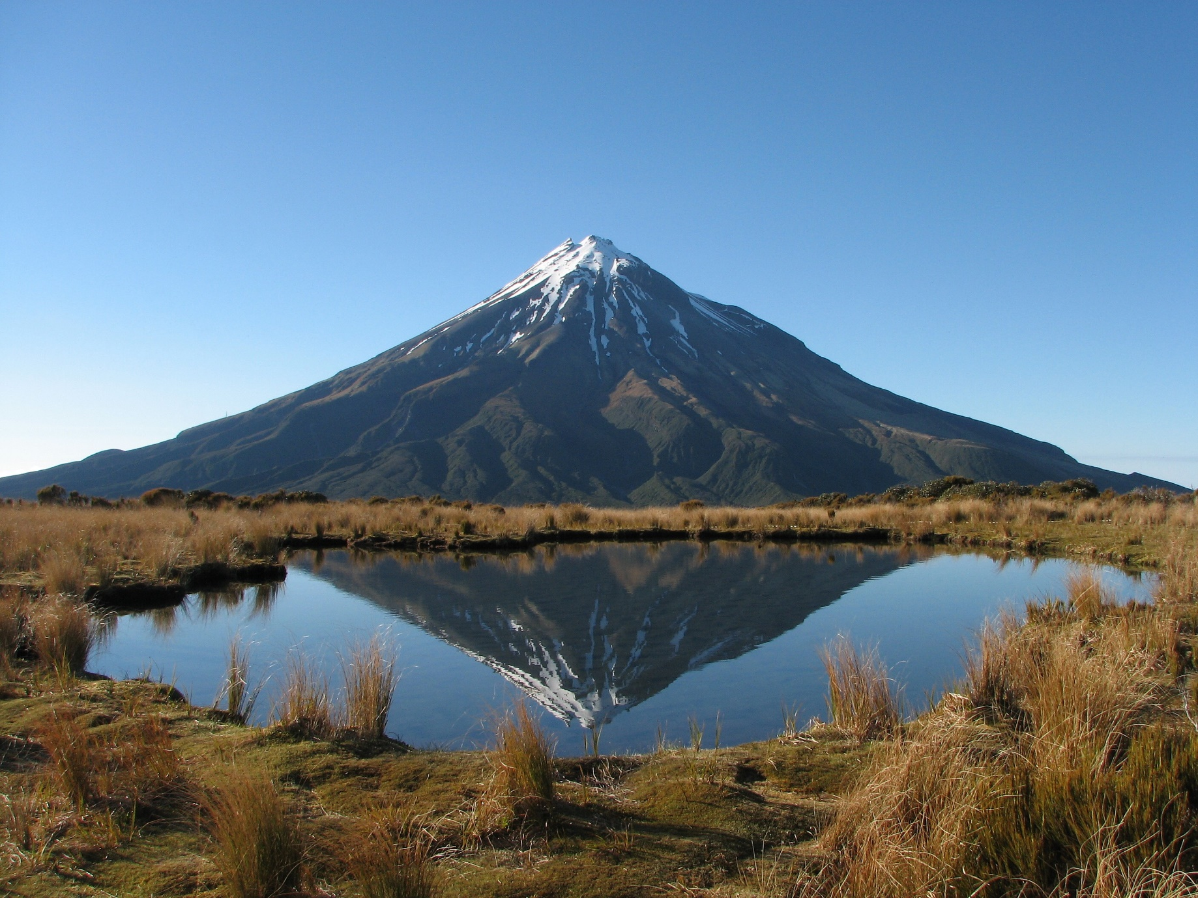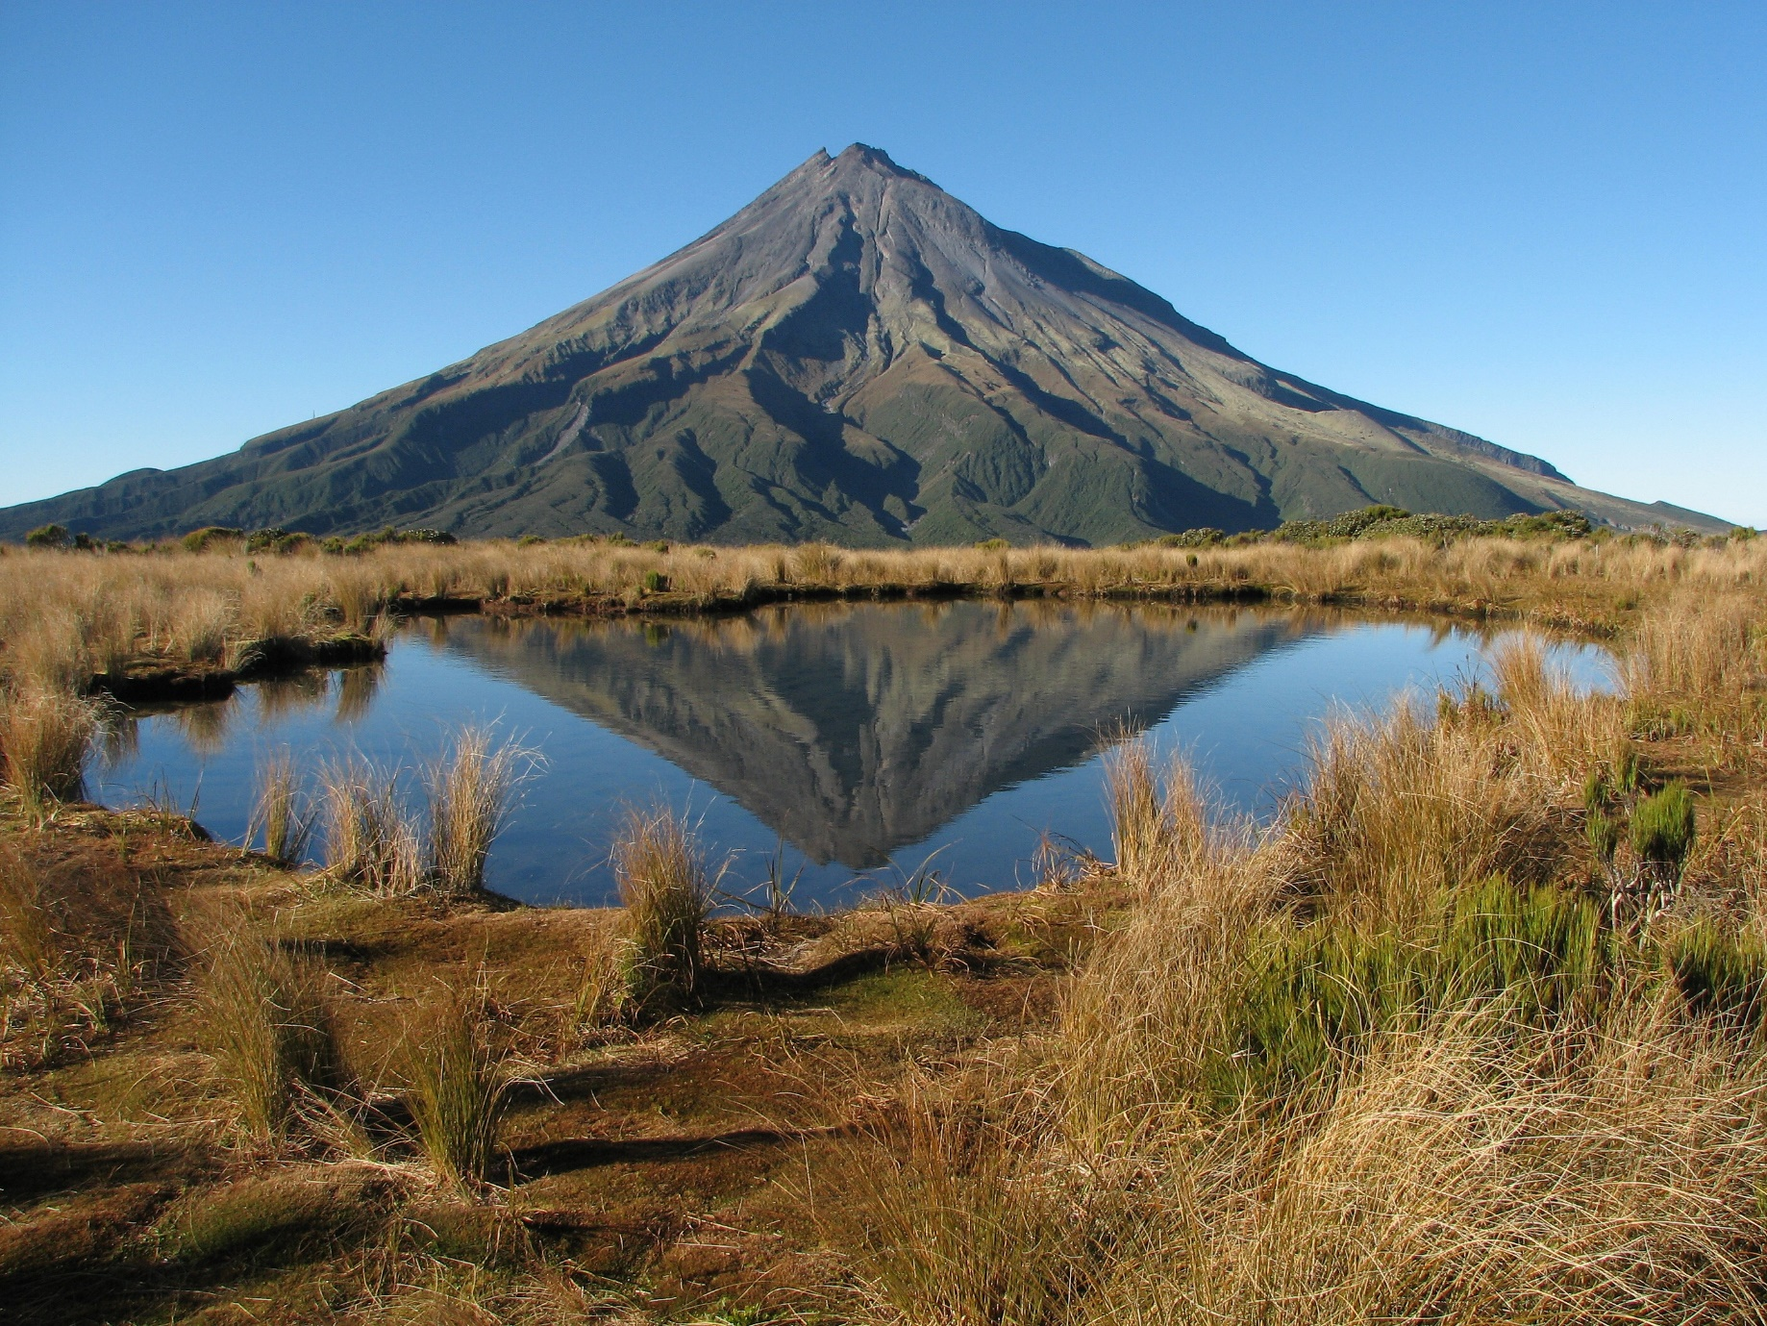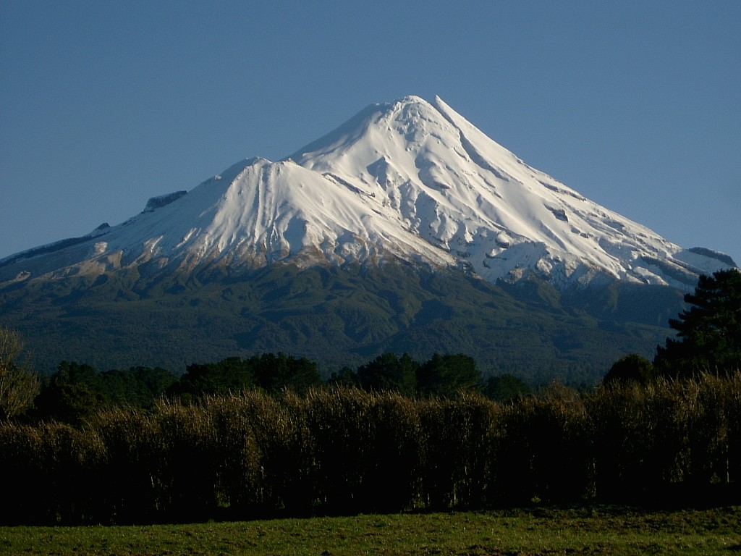
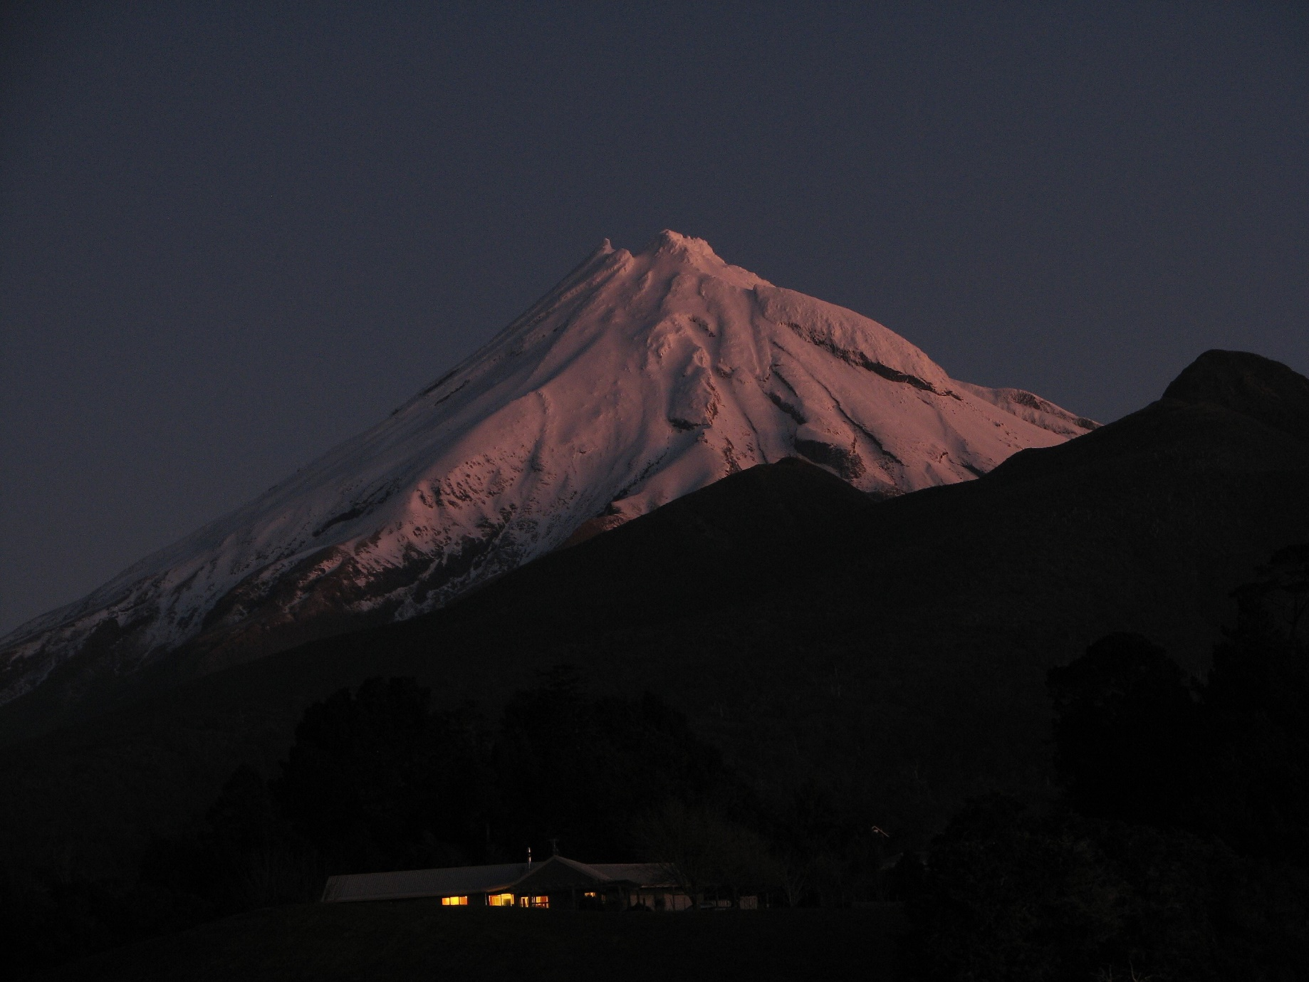
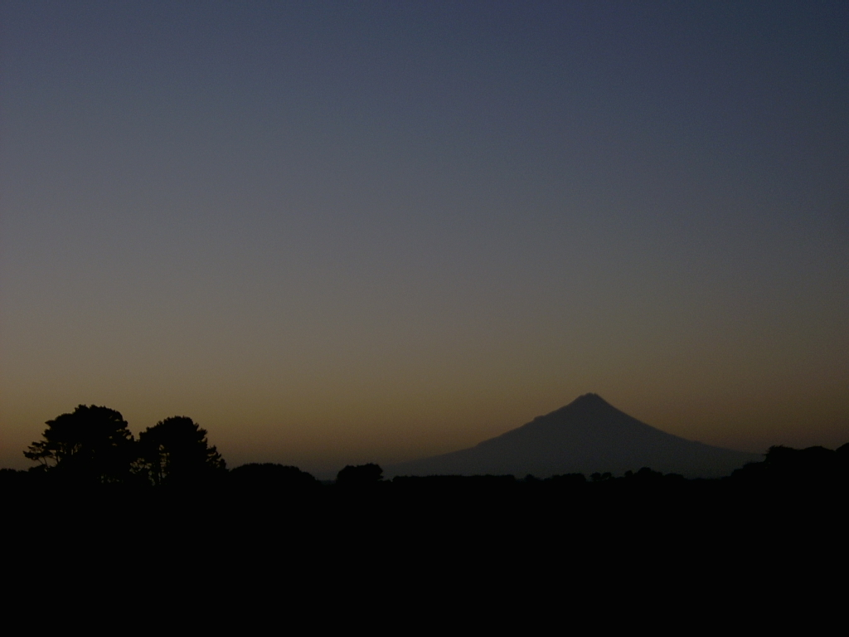

On an isolated cape a lonely mountain, clad in a cloak of pristine rainforest, looks out over rolling pastures…
A collection of photographs of Mount Taranaki, New Zealand.

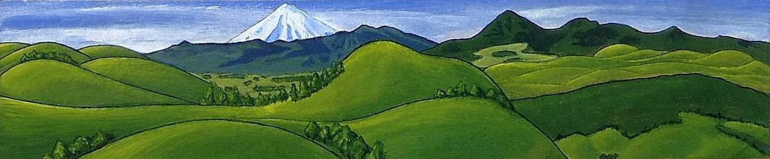

All photos by Alan Greenhead. More photography can be found at:
www.flickr.com/photos/alan_greenhead www.flickriver.com/photos/alan_greenhead/

